It is good idea to revisit this content here again.

When you start to code and looking at a cursor and thinking what do I do. Get always from the code pick pen and paper/white board and start designing.

Find that resistant on doing it on white board.It will avoid days of waste work if not designed properly.

OOP Analysis (understand)

Design (Plan)

Programming(Build)

OOPD

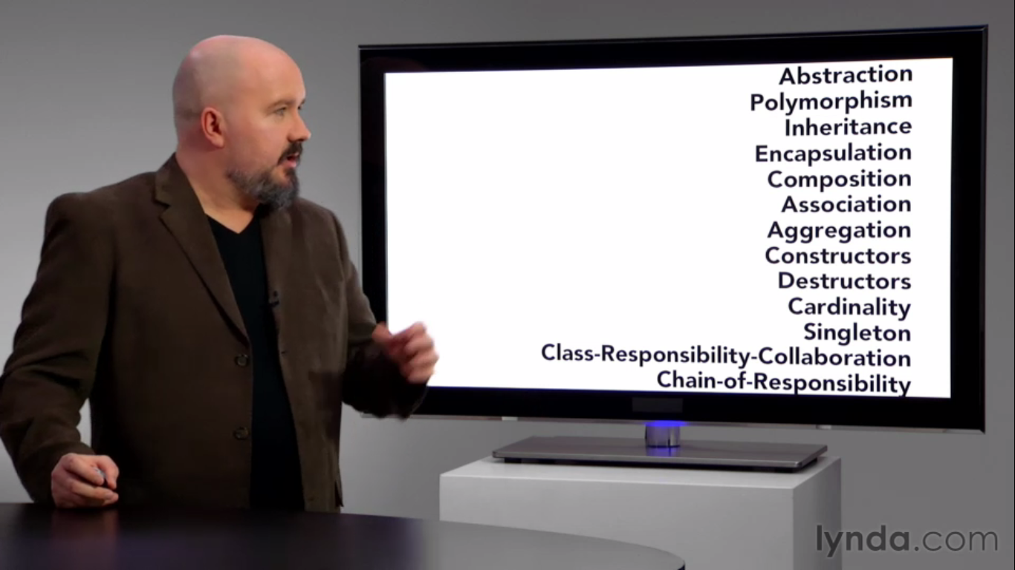

When you start to code and looking at a cursor and thinking what do I do. Get always from the code pick pen and paper/white board and start designing.

Find that resistant on doing it on white board.It will avoid days of waste work if not designed properly.

OOP Analysis (understand)

Design (Plan)

Programming(Build)

Software Development Methodologies

Agile is a iterative approach

OOP design is never perfect it supposed to be good enough.

Procedural Languages are difficult to plan on large scale.

OOP do some modularization. OOP is a paradigm.

Academic:

Prolog – Logic programming languages (PL)

Haskell – Function PL

Projects or industrial

C++, Java

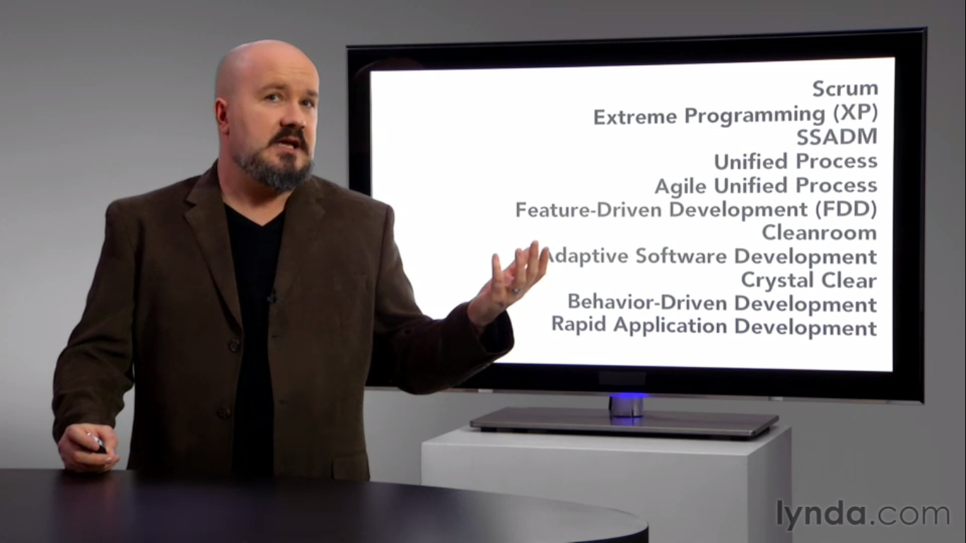

**Object**

Object different from other objects as apple is different than Cup.

The inherit property as cup is full or empty.

Lamp can be off or on.

Attribute = color, size

**Identity, attribute and behavior**

Objects are not always physical items

Objects are not always visible items

Saving, printing are the behavior of an object.

**Class**

Blueprint of object not the object.

Name, attributes,

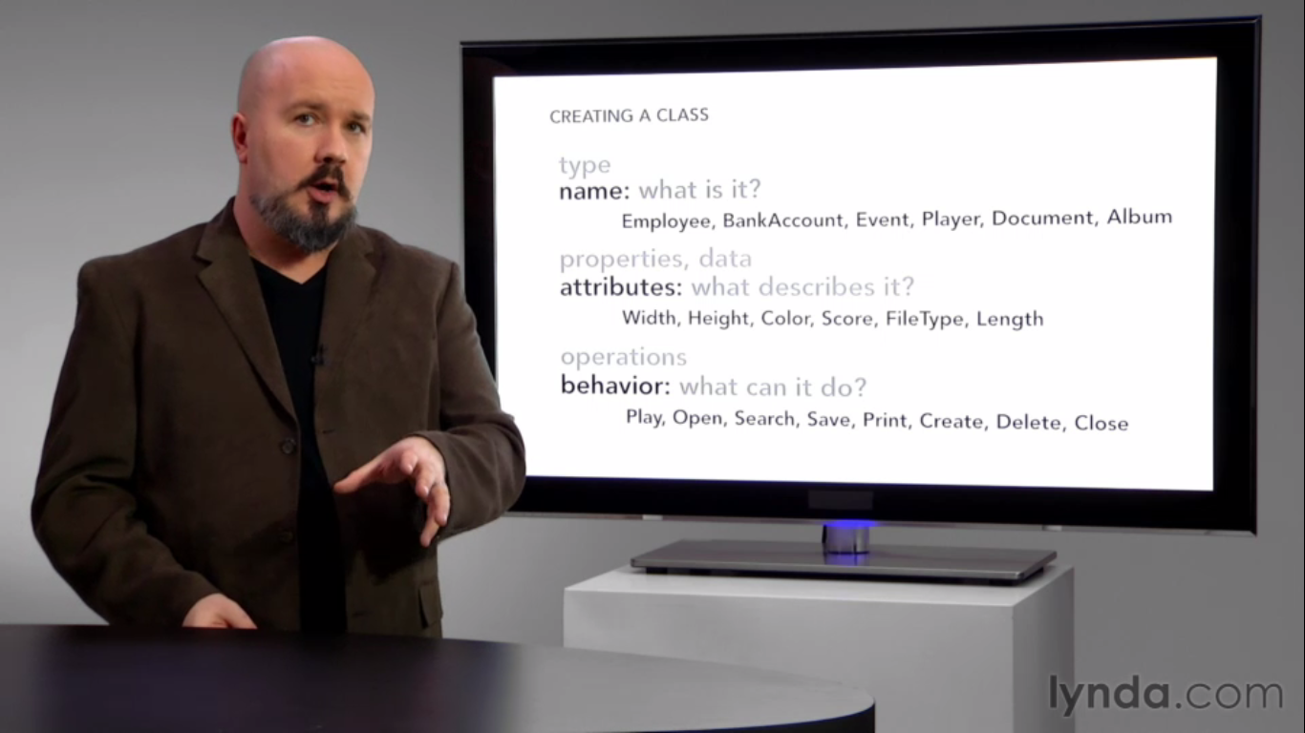

Methods are functions.

Each behavior of an object is independent.

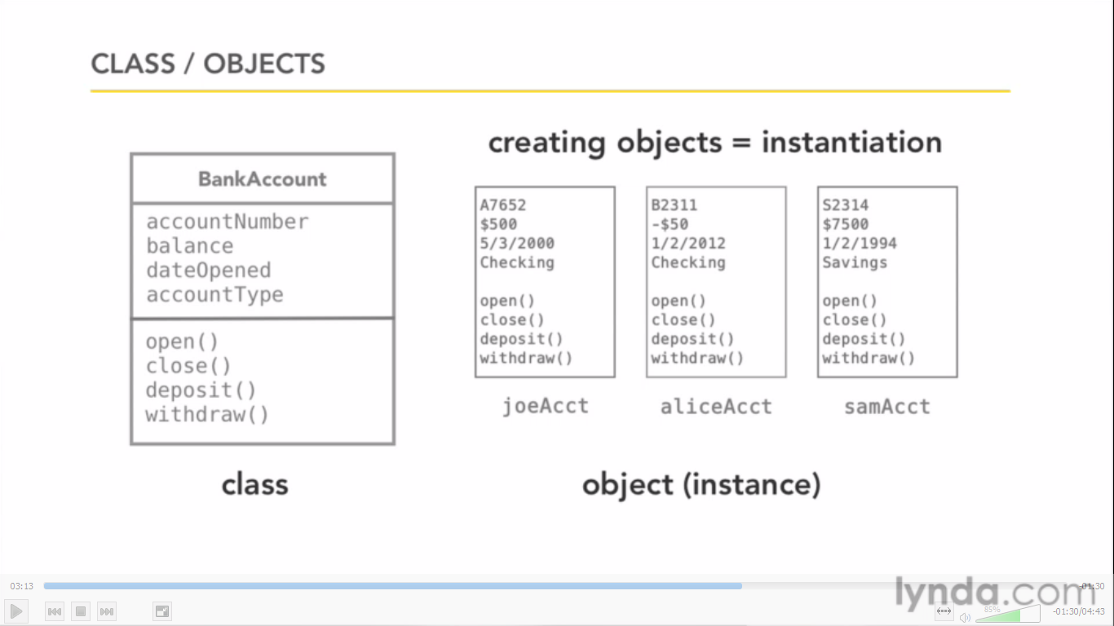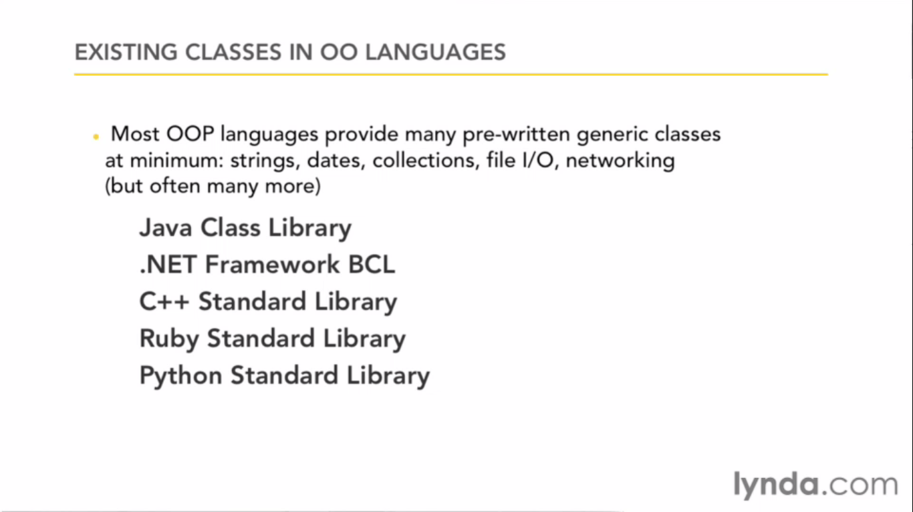

APIE

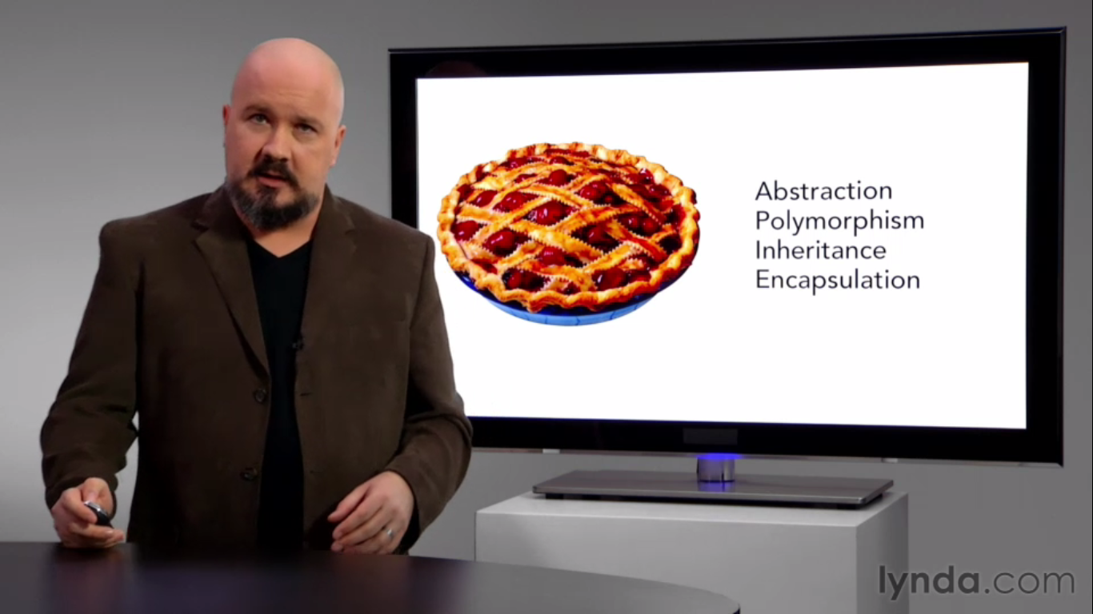

Abstraction

When I tell you table you know what table is. I don’t have to give you any details.

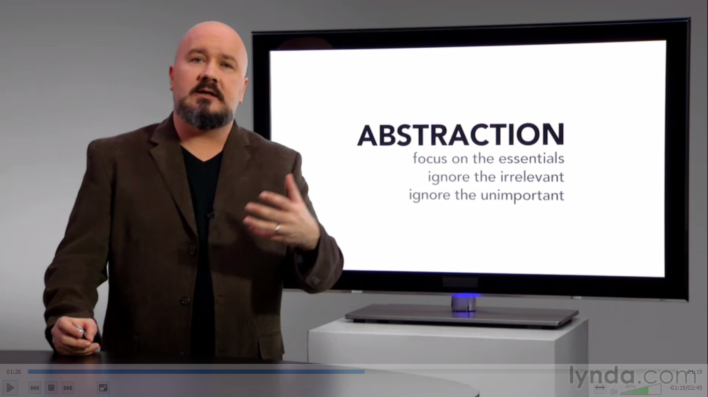

Focusing on the essentials

What this bank account class should look like under these circumstances.

Encapsulation

Medication Capsule or Food Container.

Taking attributes and behaviors and bundling together.

Control access by different behavior

Its Black Boxing.

You don’t need to know how telephone works.

If change then to only one class.

We hide so change at one place should not affect other places.

Inheritance

Code reuse

Person <- inherits Customer

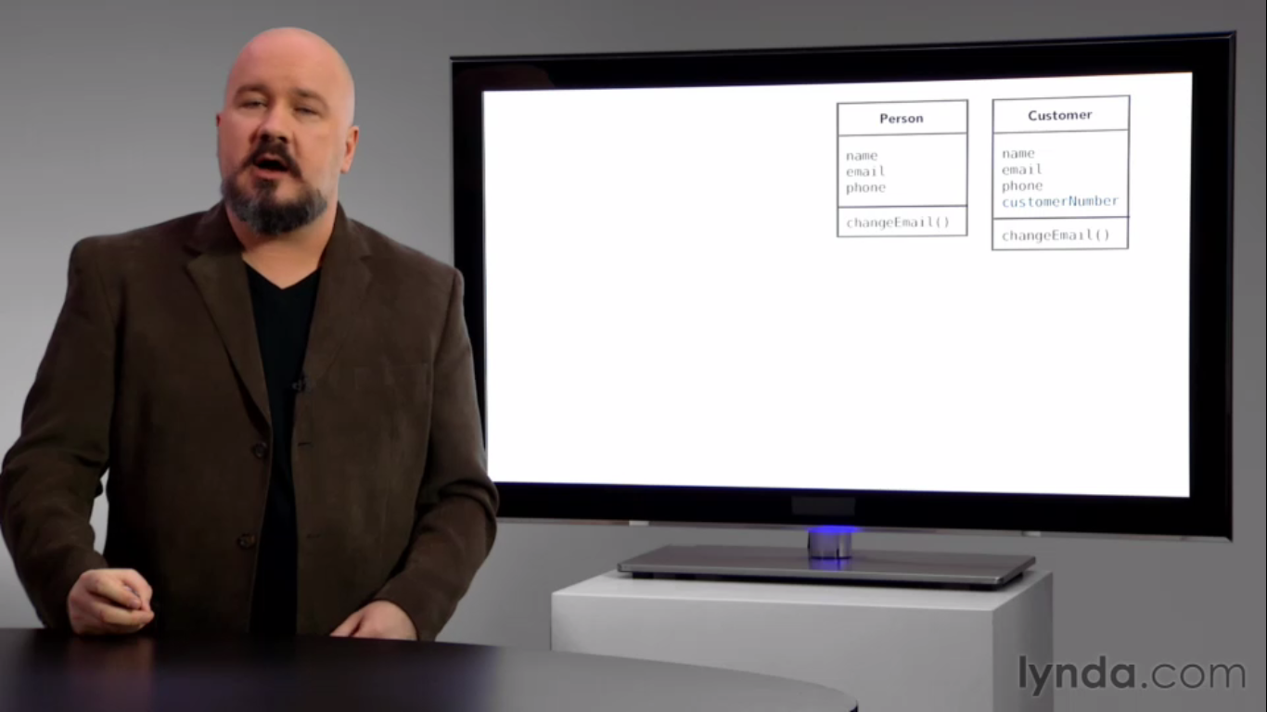

C++ Inheritance from more than one super class.

Java,C#,Obj C, Ruby- Single inheritance only inherit from one super class.

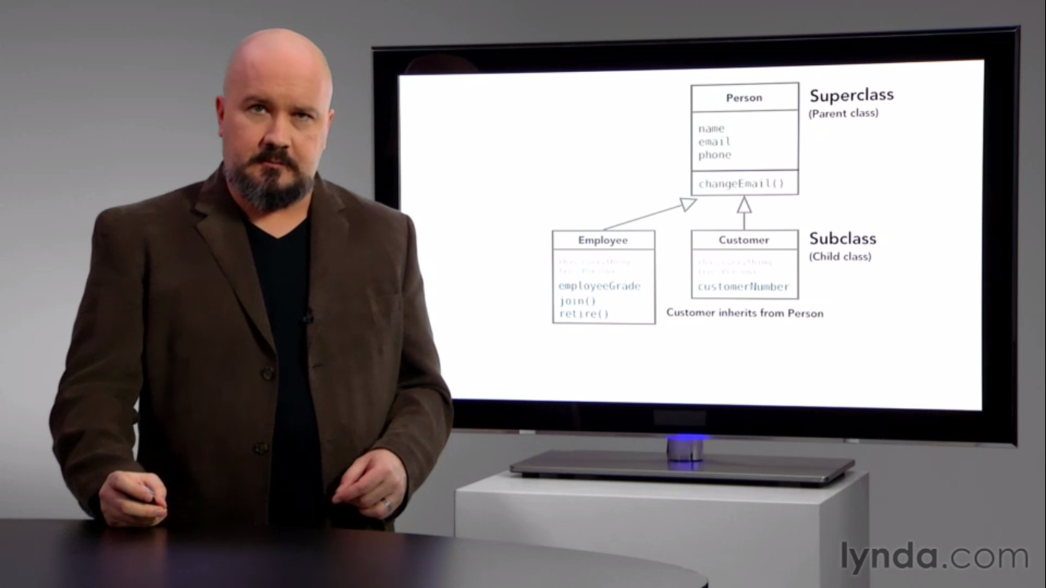

If I make changes in super class, it will automatically inherit to its sub classes.

Polymorphism “many forms”

+ - add them or concatenate them

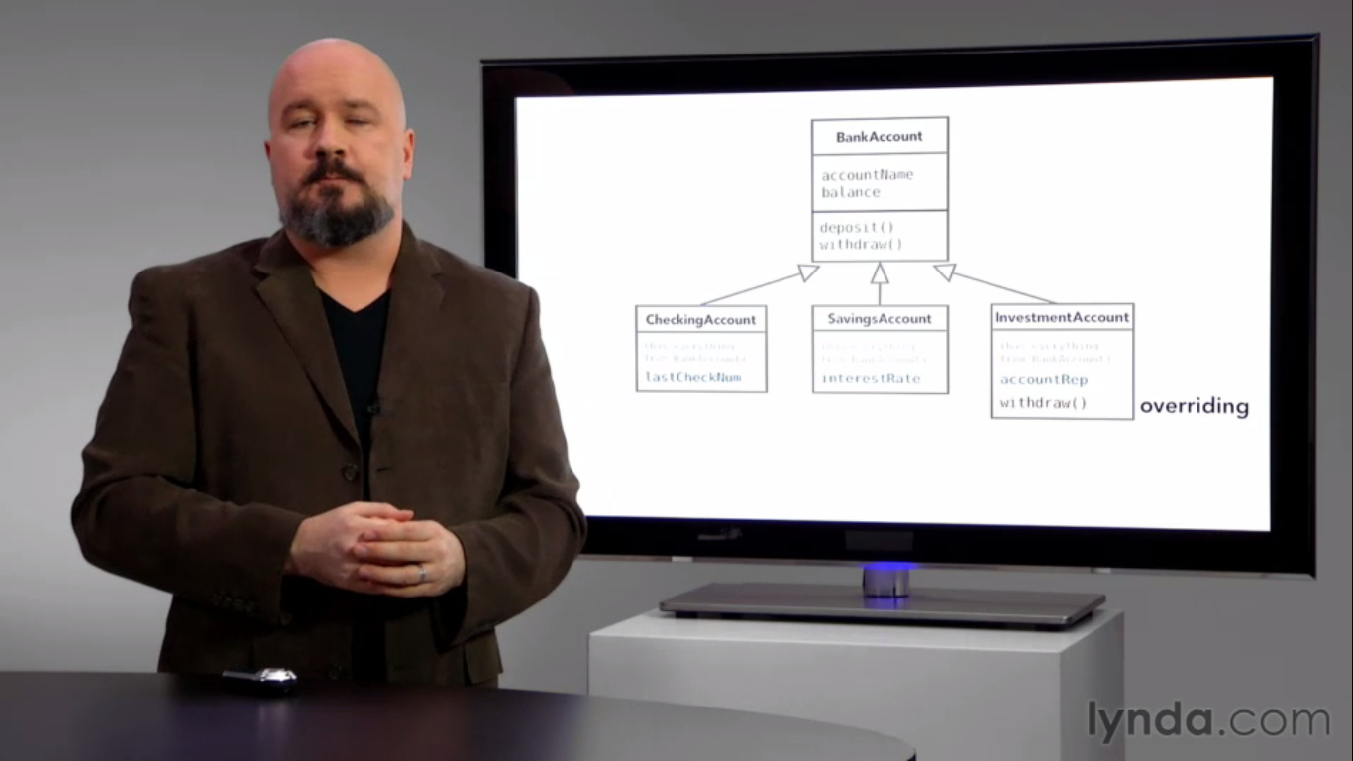

You have a withdraw method in back account and as some one withdraw form investment account it should get some penalty so you inherit and override it which is overriding.

Gathering Requirements

Non functional req

Documentation

Legal rules as tax vary country to country

Performance – Response time how many people will access.

Initially what that must do not about can do or might do. What is basic thing it should do. Main idea.

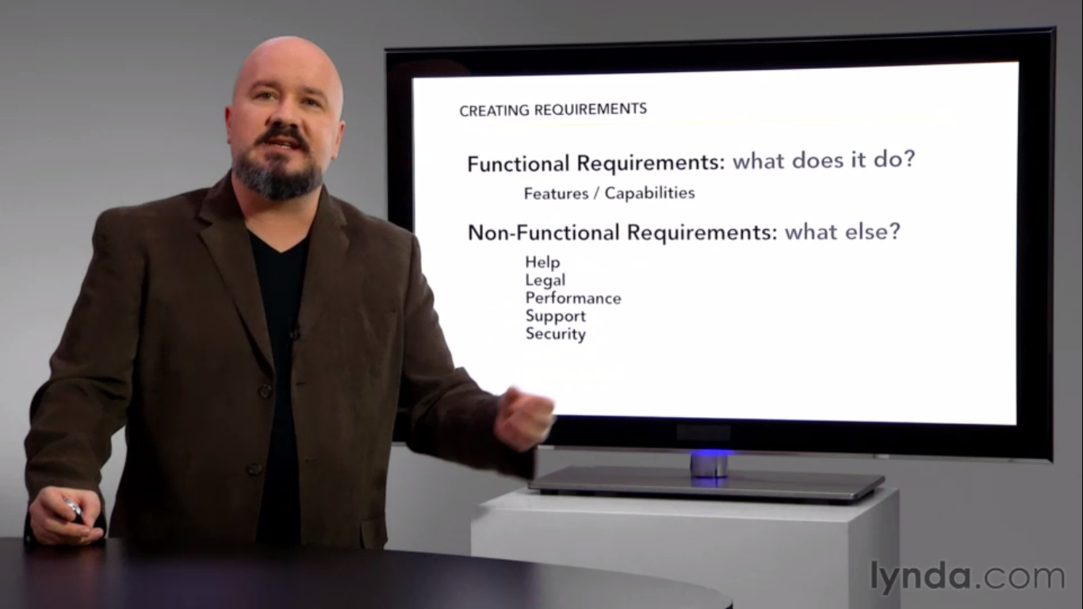

Functional Requirement Examples

System must display the heart rate, temperature and blood pressure of a patient connected to the patient monitor.

Application must allow user to search by customer’s last name, telephone number or order number.

Program must allow receipts to be generated via email.

Application must allow user to create 140-character message.

Application must Continue to function without network connection.

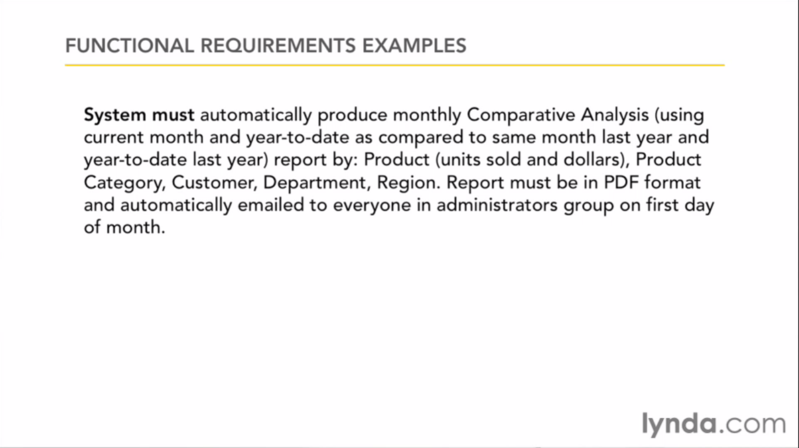

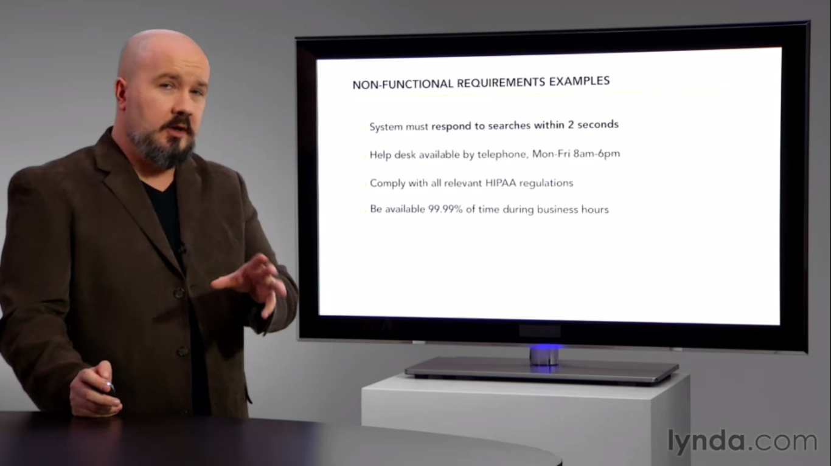

FURPS/FURPS+

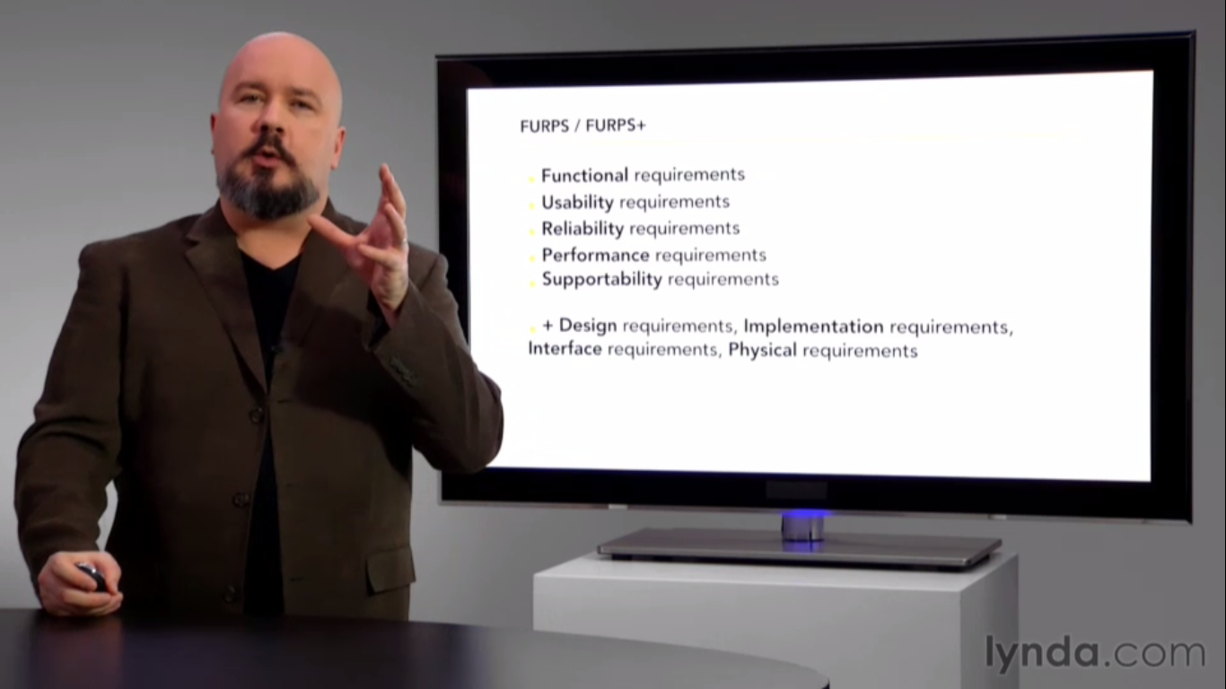

Simple acronym to check did you think about this.

Not the dream feature not focusing on that

You requirement will change

It’s a checklist

What all use for

F – features of the app

U- Help documentation, tutorials

R- Failure rates, disaster recovery

P- Availability, capacity and resources.

S- Global, internationalized

D- IPhone app or relational data base

I – What language must be used.

Interface – Integrating with other system which need to be specified it now.

P- Needs to run with a device with a camera or shipped with a dvd

We don’t what that buzz words polymorphism or inheritance at this point we want something written down like bullet point what you want. Set of requirements.

Use Case

Don’t overdo it. Don’t spent too much time on it. It’s never going to be perfect.

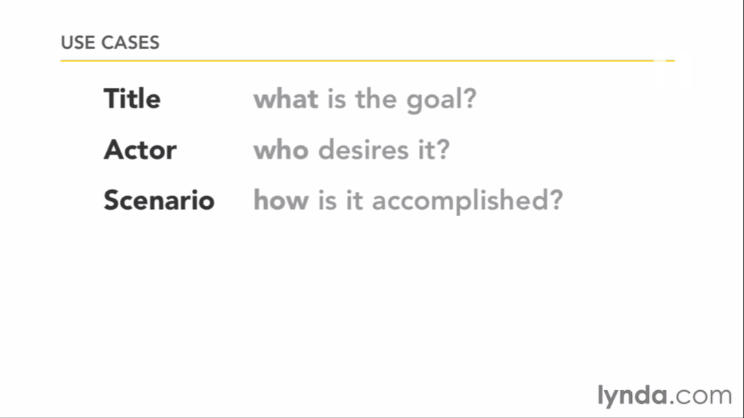

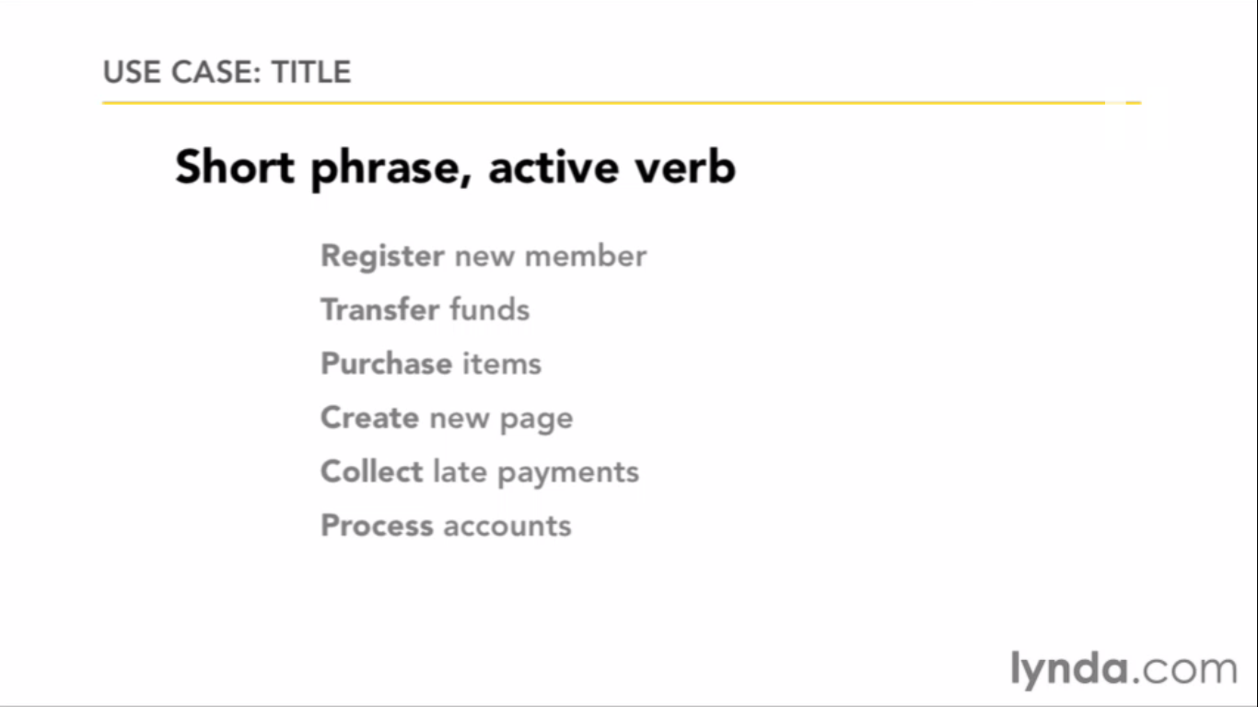

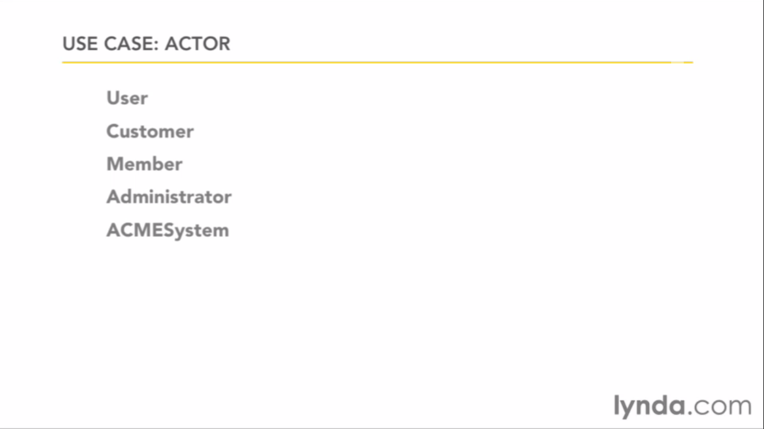

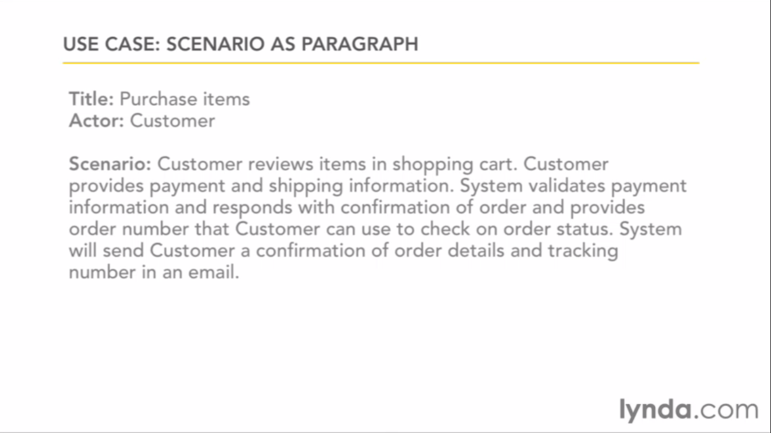

Or the step by step

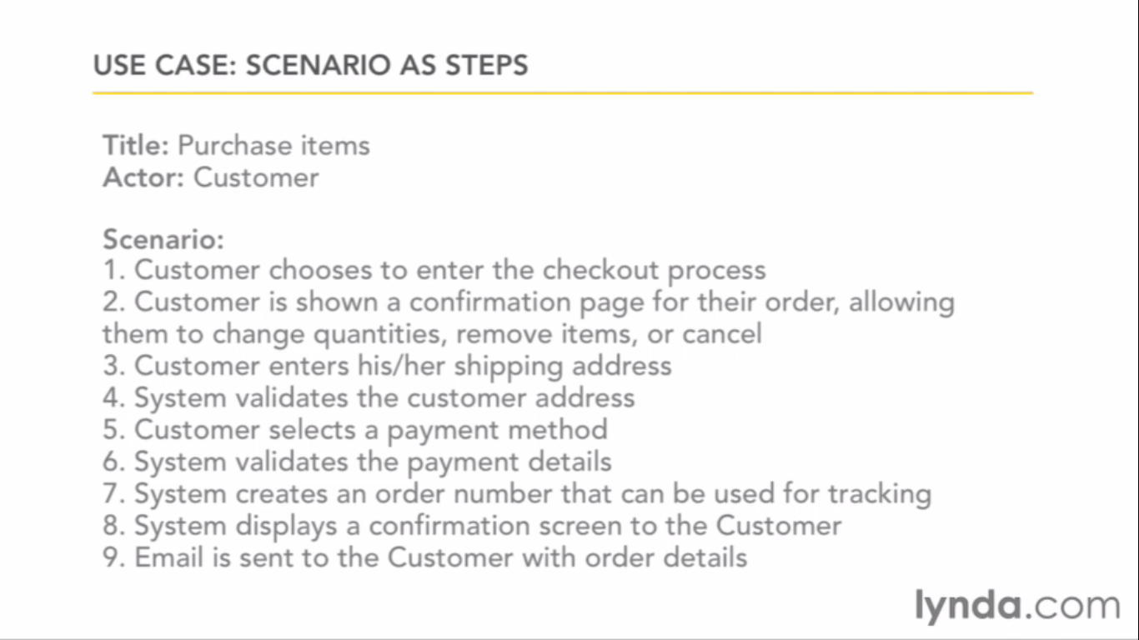

Adding some extensions or preconditions in it

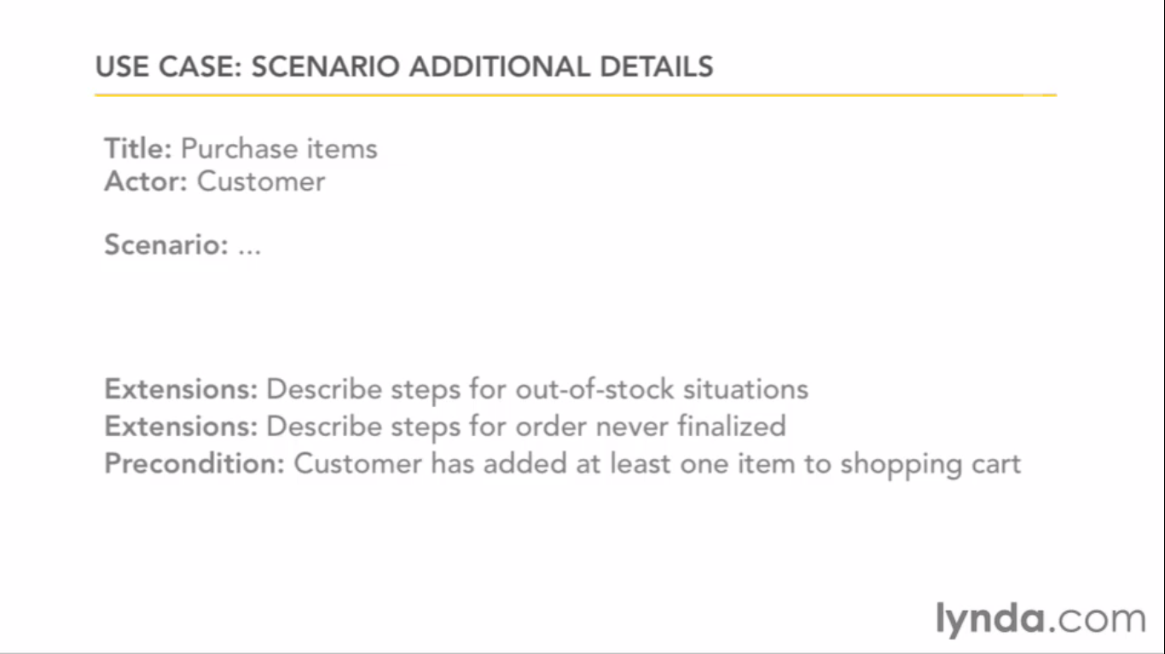

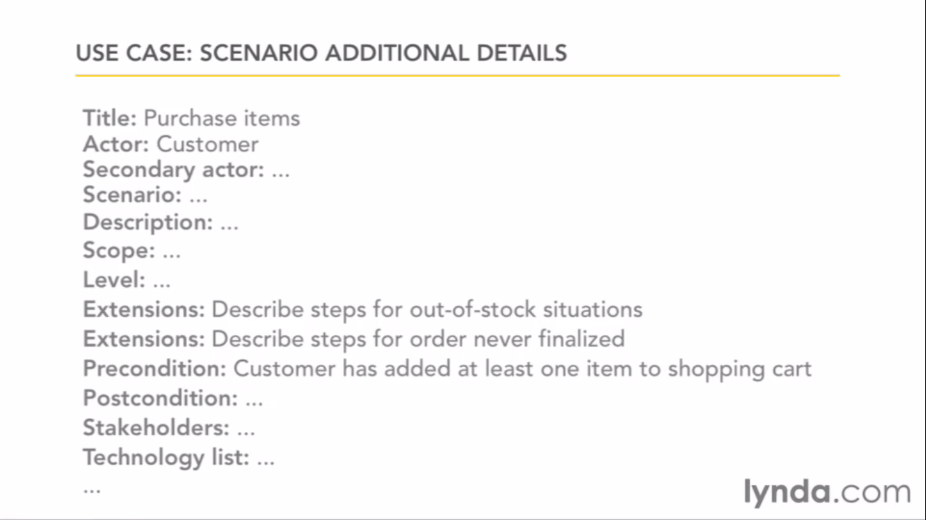

Some people do it more detailed like this which does not work some times. Its better to be simple.

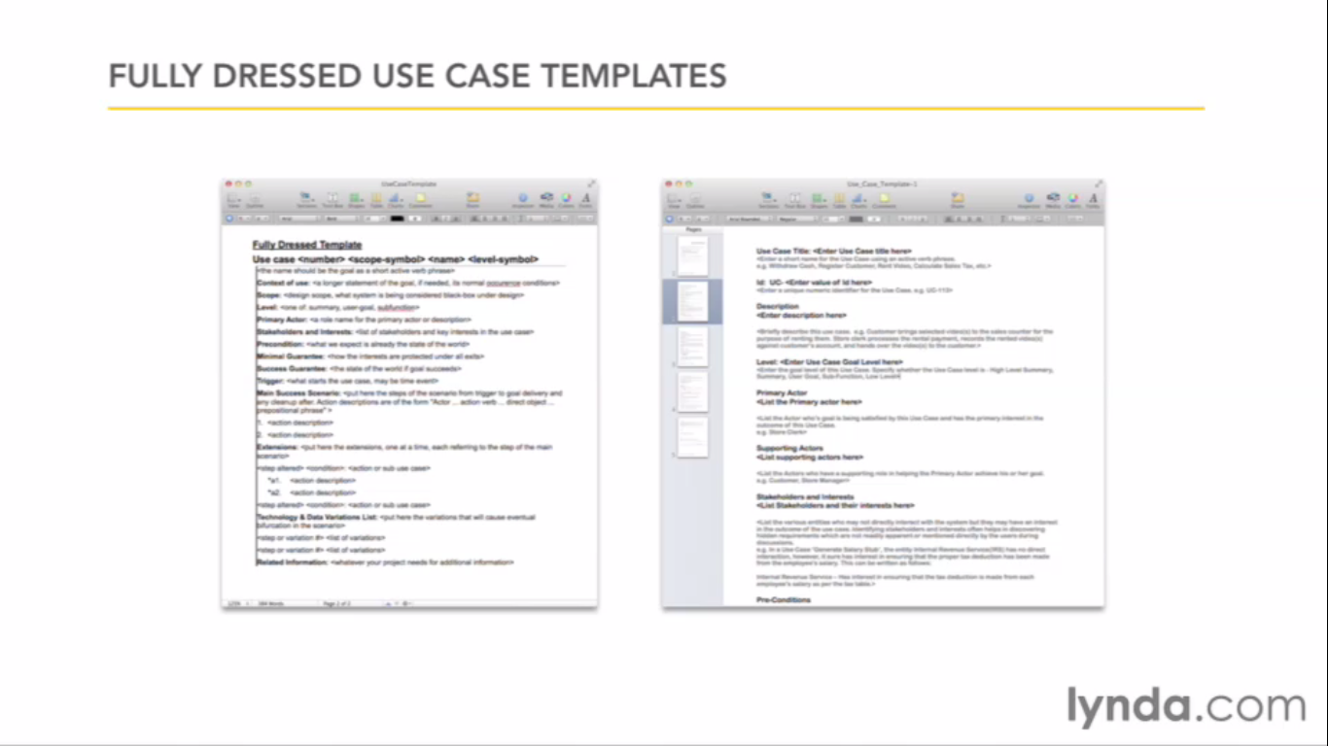

Actor

Actors can be human or machine

So there will be people who want to access the resource such as Expense Approval System.

Here we say Requestor(Primary Actor) and Approver(Secondary Actor).

Actors success depends on the scenarios.

Scenarios

Scenarios are those not to frequently or heavy but those which has set of functionality to perform

Multiple Scenarios

Sunny day scenarios are those when every thing goes well.So, We add extensions to support and cover

Extensions are technical situations can occur.

Be simple readable and Active voice.

Focus on Intension

Have some rough Use Cases. So In next step you can connect them all more properly.

Diagramming Use Cases

User Story

Single small senario

User specific what they want to do.

It is just short 3-4 like

As a User (type of user)

I want to serach by keyword (goal)

so that I can find and read relevant articles (reason)

Explaining in simple language is always use full as it has many next steps to describe.

Domain Modeling

Conceptual Modeling

Identifiy most important objects in your app.

Not all will form into classes or objects. It will show how are they interact.

Few hours is enough. Don't worry about the perfection.First time it will be incomplete and its normal. As you will figure out in future.

Codeproject

SRP - The Single Responsibility Principle -

A class should have one, and only one, reason to change.

OCP - The Open Closed Principle -

Should be able to extend any classes' behaviors, without modifying the classes..

LSP - The Liskov Substitution Principle-

Derived classes must be substitutable for their base classes.

DIP - The Dependency Inversion Principle-

Depend on abstractions, not on concretions.

ISP - The Interface Segregation Principle-

Make fine grained interfaces that are client specific.

In software world the concept of dividing and conquering is always recommended.

Ways of encapsulation:-

Creating class to bind methods and attributes.

The interface can be used to hide the information of an implemented class.

Both Aggregation and Composition are types of Association.

Association(has-a)

a teacher *has-a* or *teaches* a student. There is no ownership between the teacher and the student, and each has their own life-cycle.

Aggregation(uses) week type

a school department *uses* teachers. Any teacher may belong to more than one department. And so, if a department ceases to exist, the teacher will still exist.

Composition(owns) Strong type

a department *owns* courses, which means that the any course's life-cycle depends on the department's life-cycle. Hence, if a department ceases to exist, the underlying courses will cease to exist as well.

In Summary,

we can say that aggregation is a special kind of an association and composition is a special kind of an aggregation. (Association->Aggregation->Composition)

Identify the Classes

Find all the nouns from the Use Case Scenarios and remove all the duplicates.

Sometimes attributes can be in noun list.

Just draw boxes using boxes. It helps to show the relationships between them.

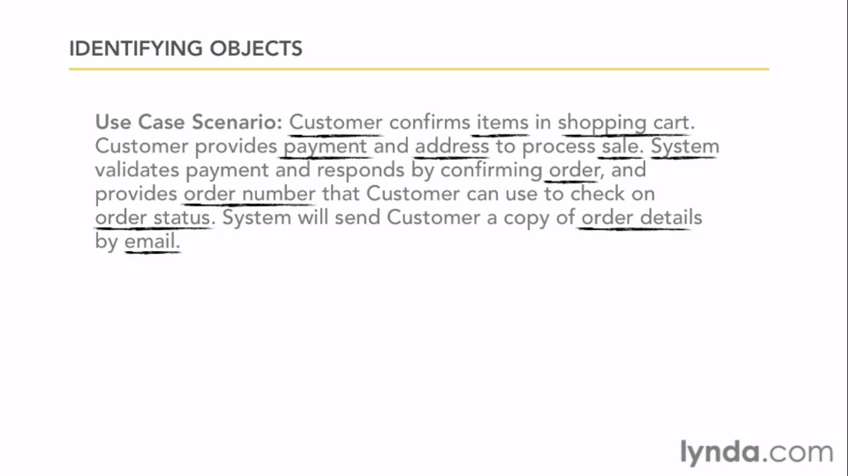

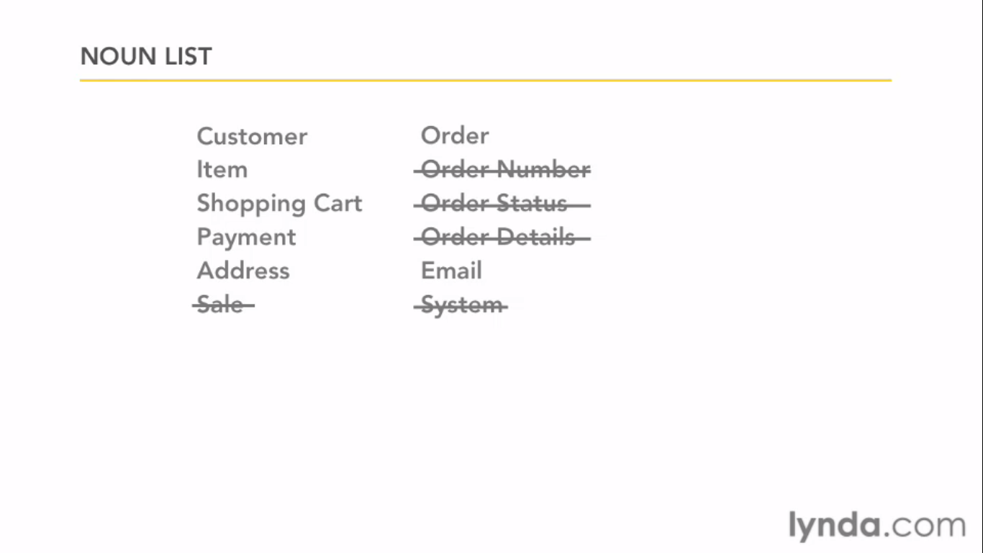

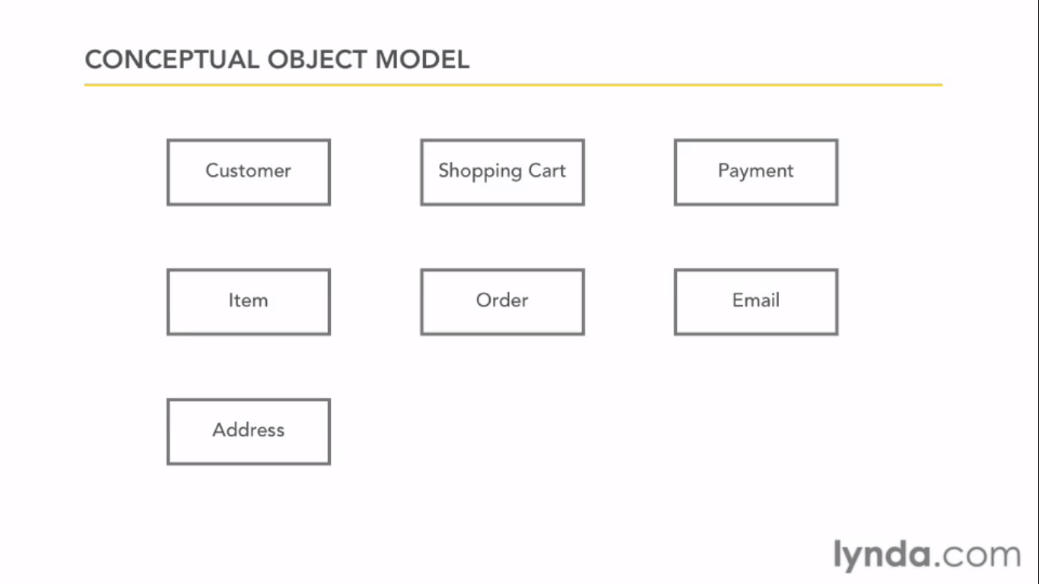

Pulling out the verbs which will act as a Use Cases.

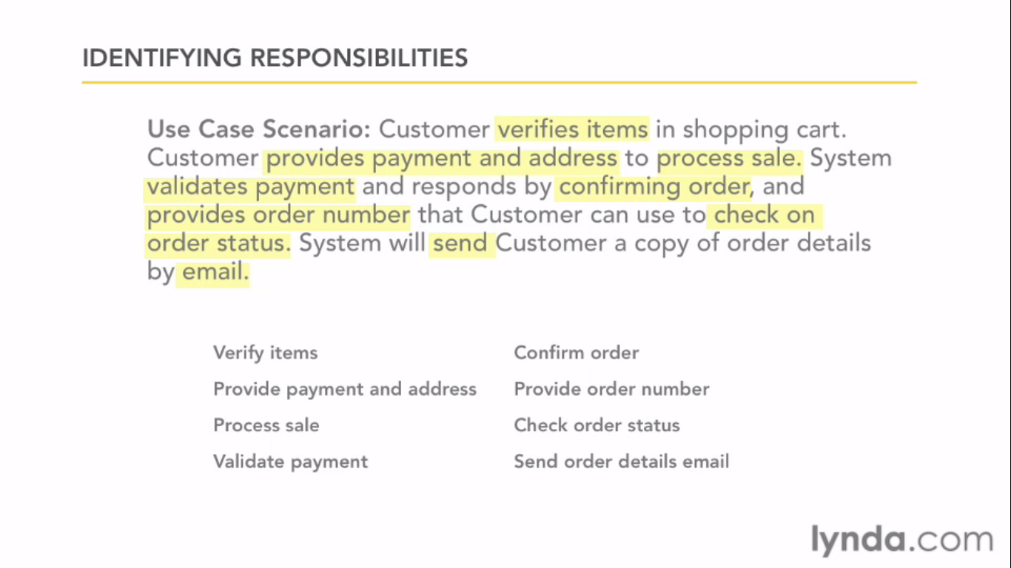

Here Object should be responsible for it self

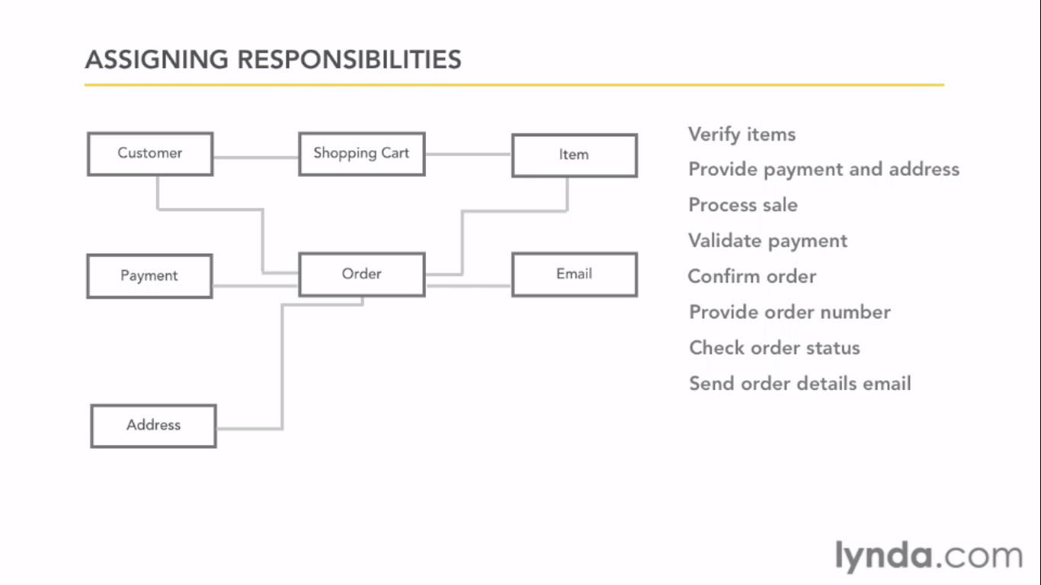

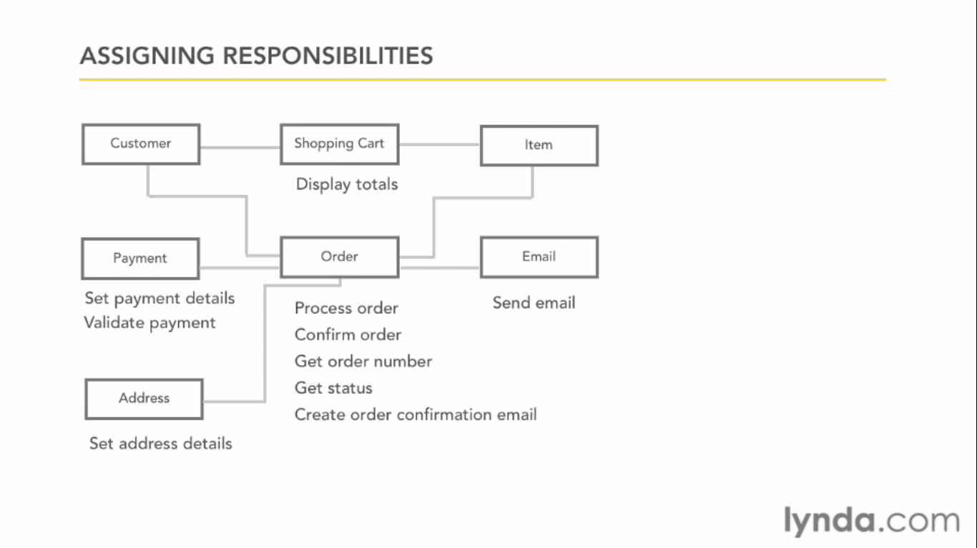

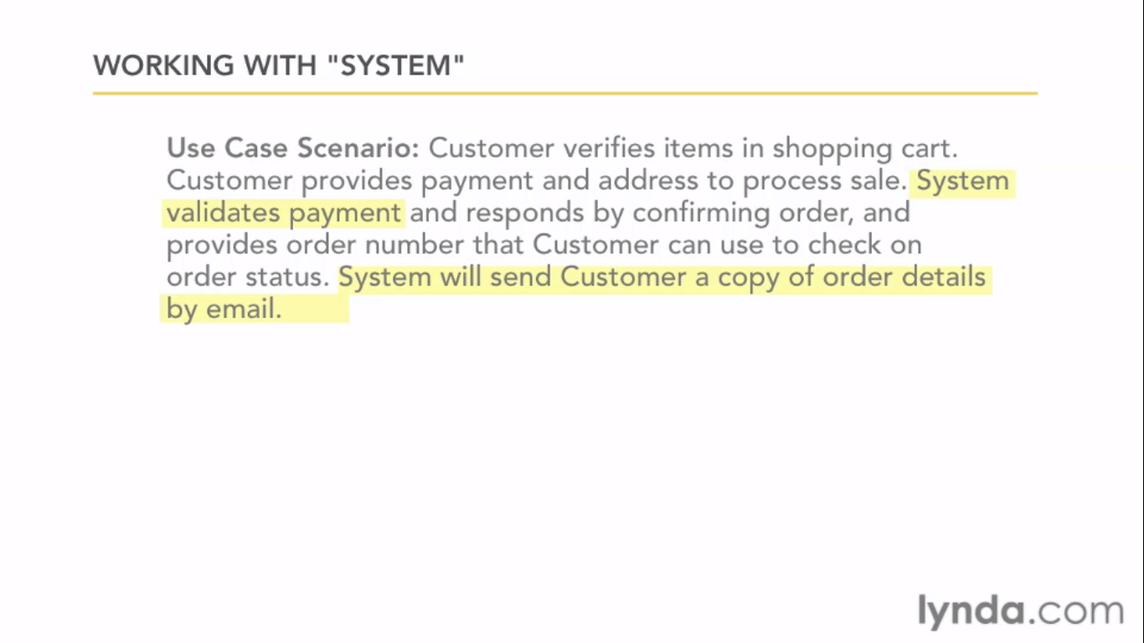

It says it should be there in at some place.

Avoid Global master object. All the behaviors need to be in their class. No special behavior are declared outside the class.

Responsibility should be distributed well.

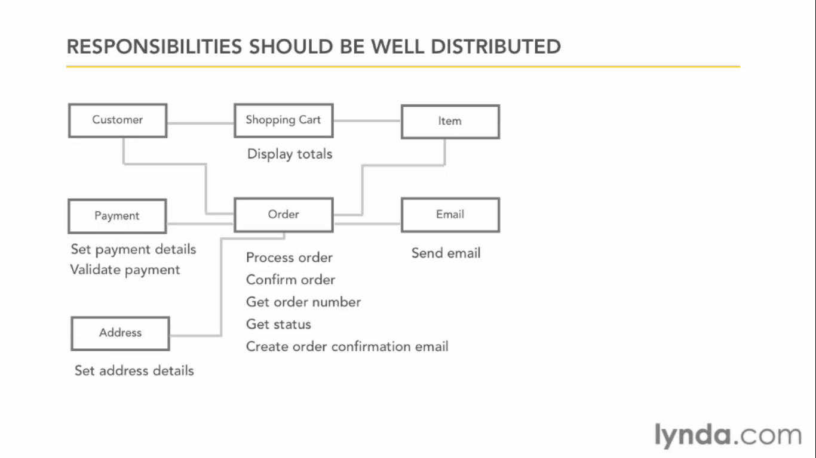

Class responsibility collaboration

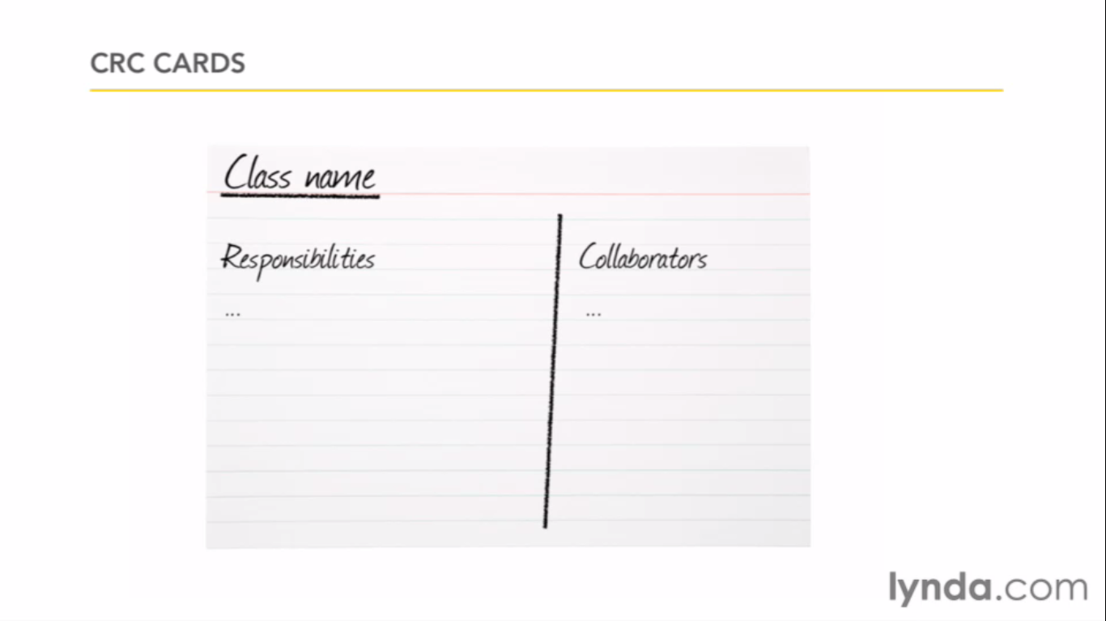

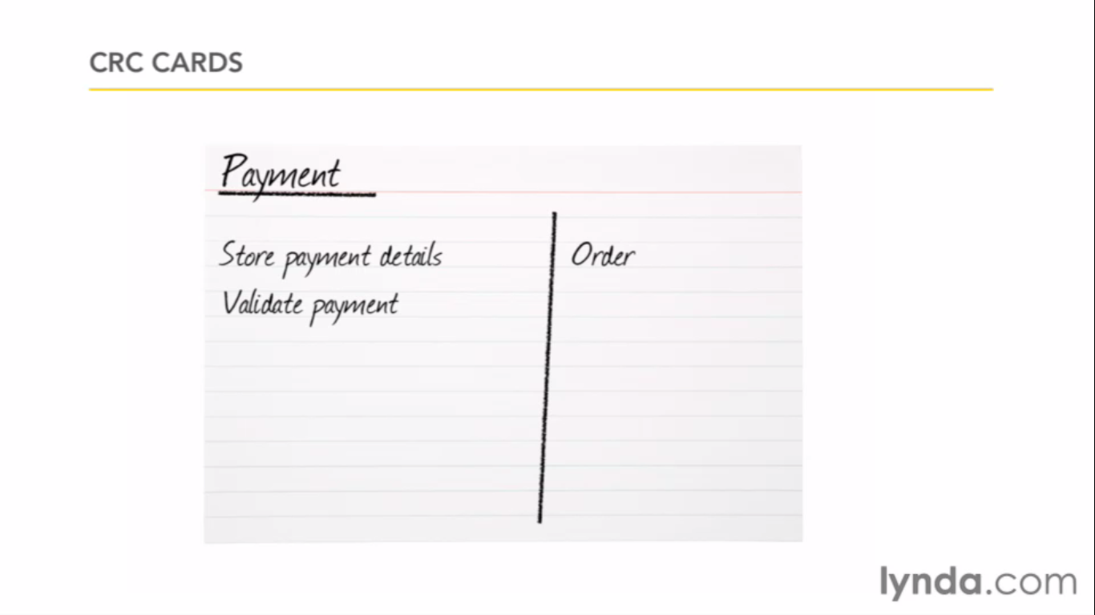

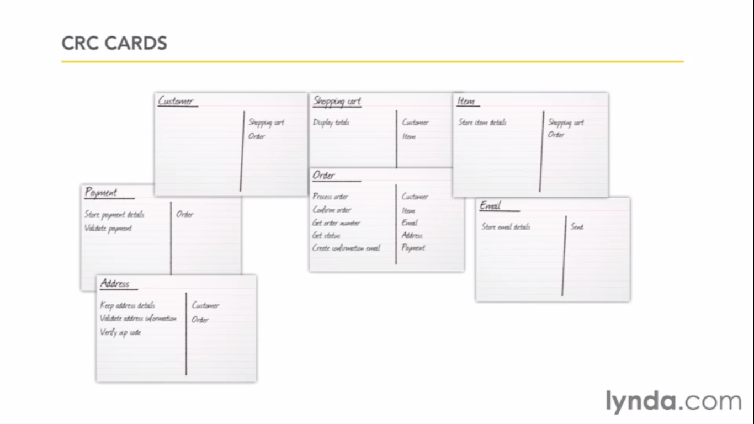

Class UML diagram

+ public

- private

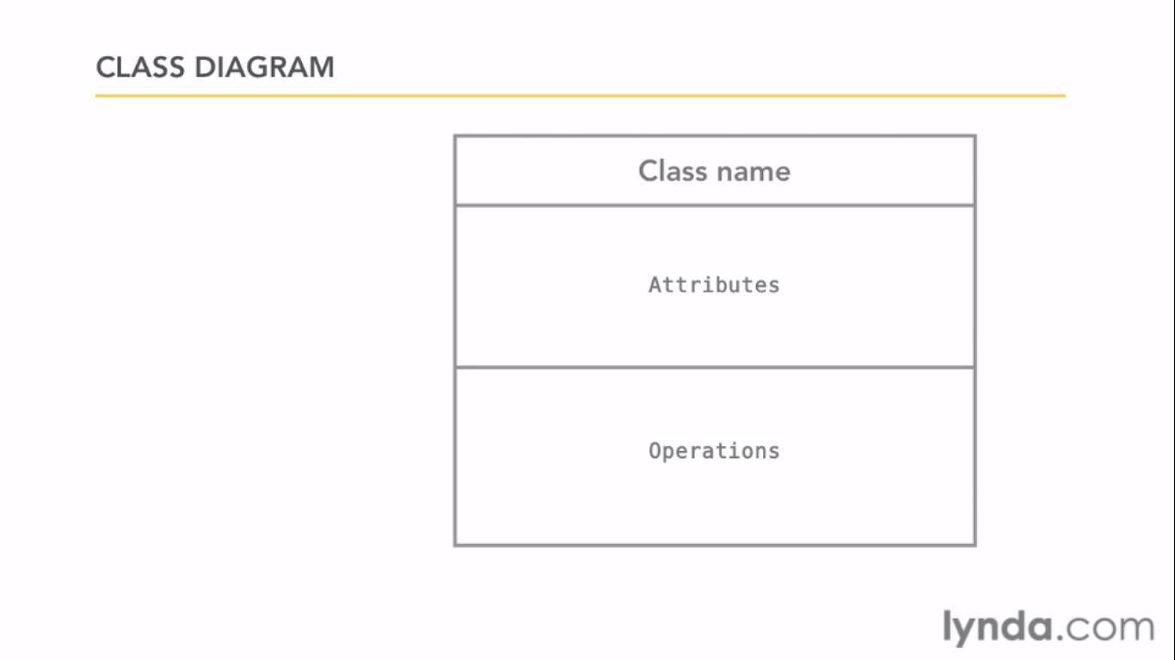

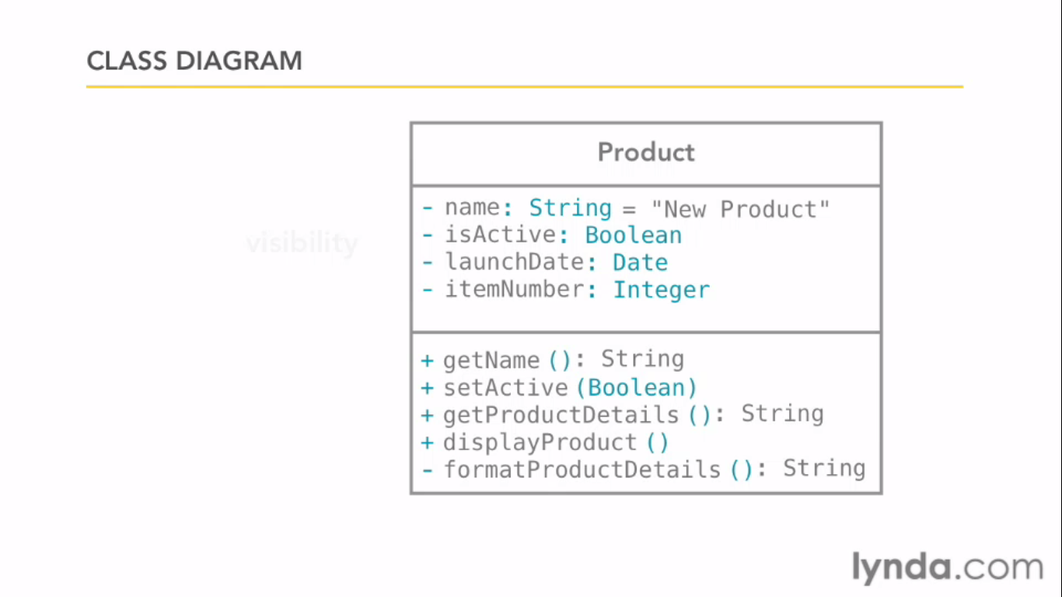

Common mistakes people do is they write obvious attributes.

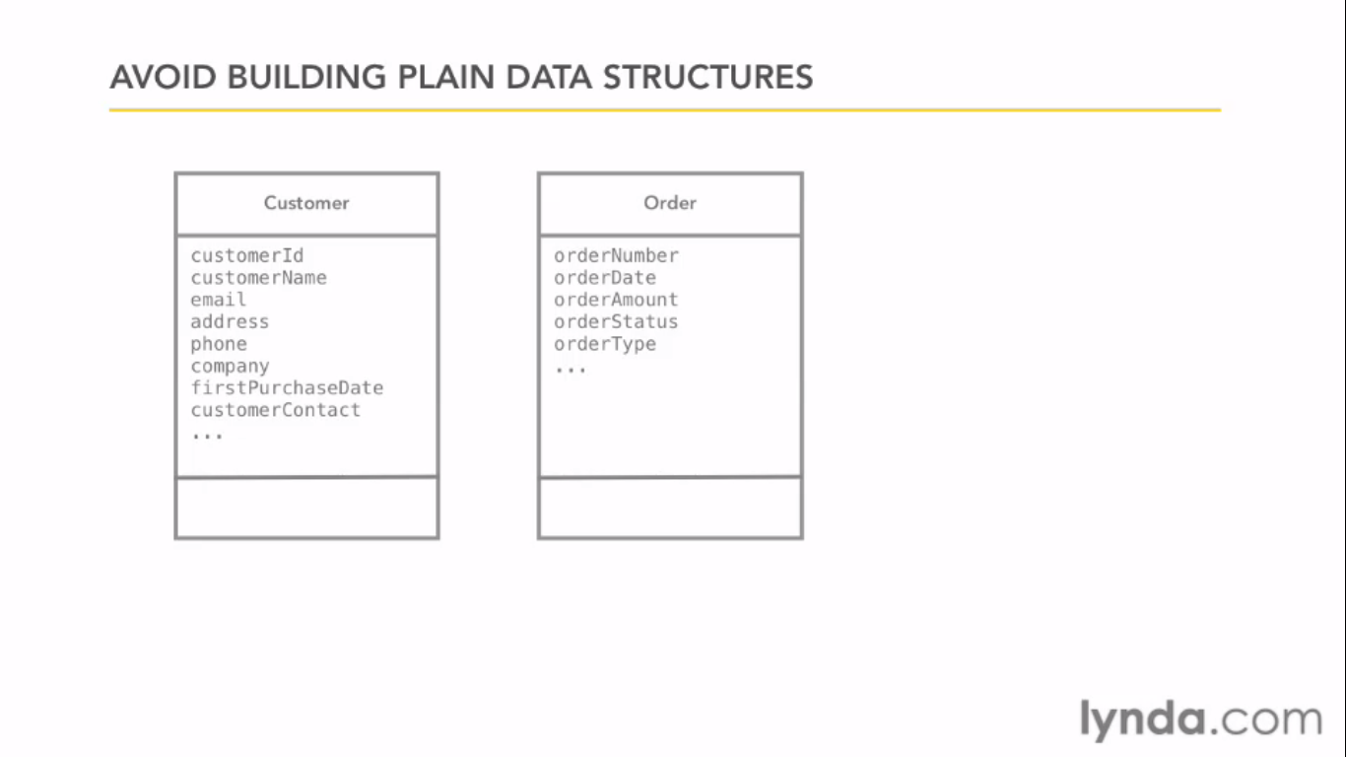

Class to Code

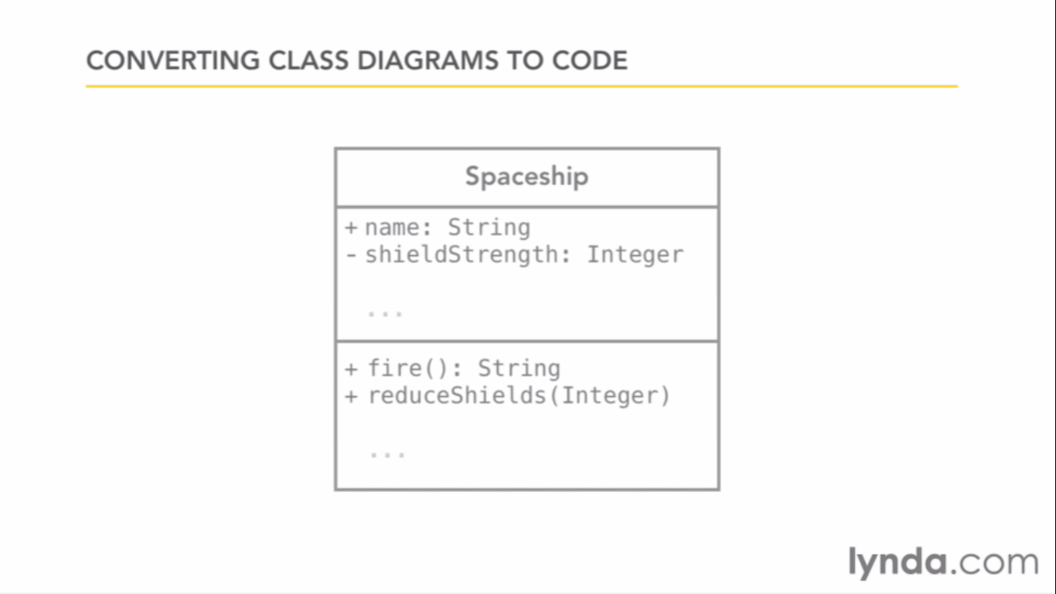

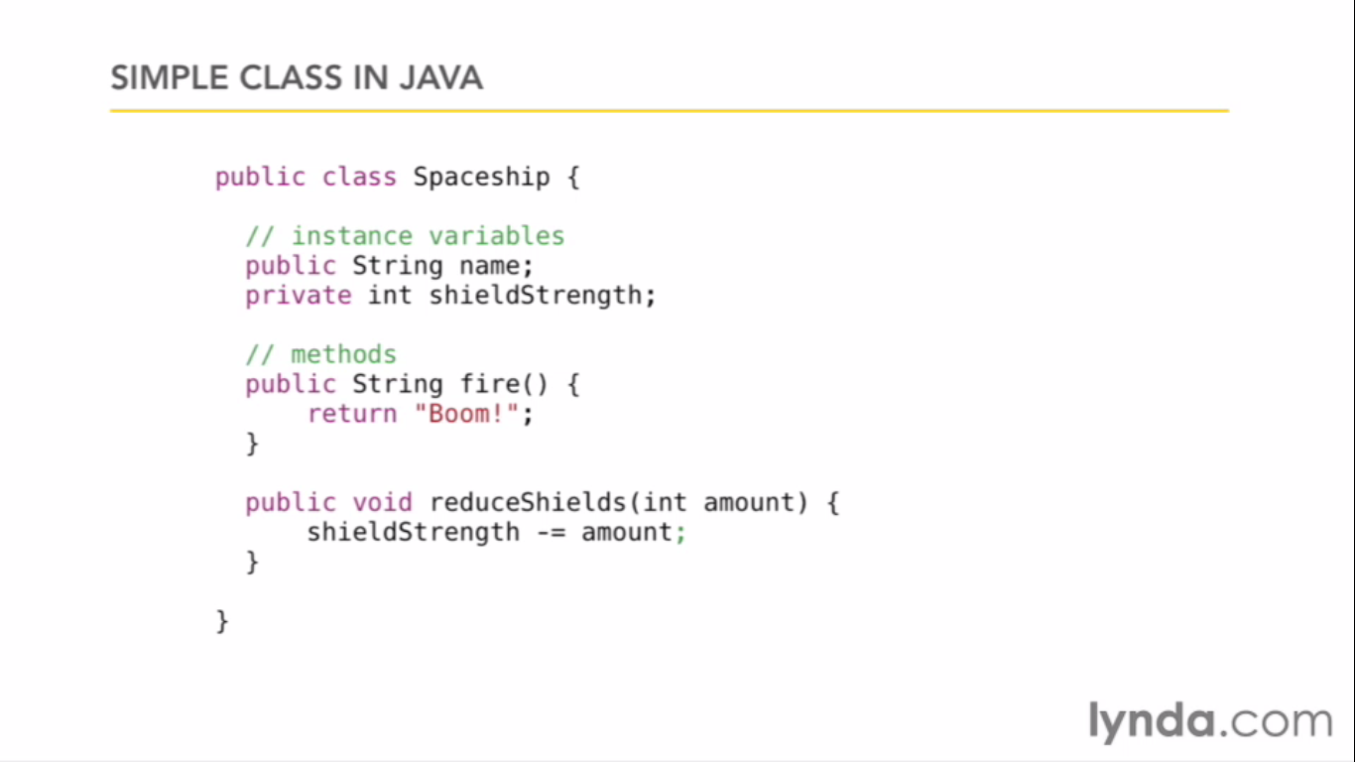

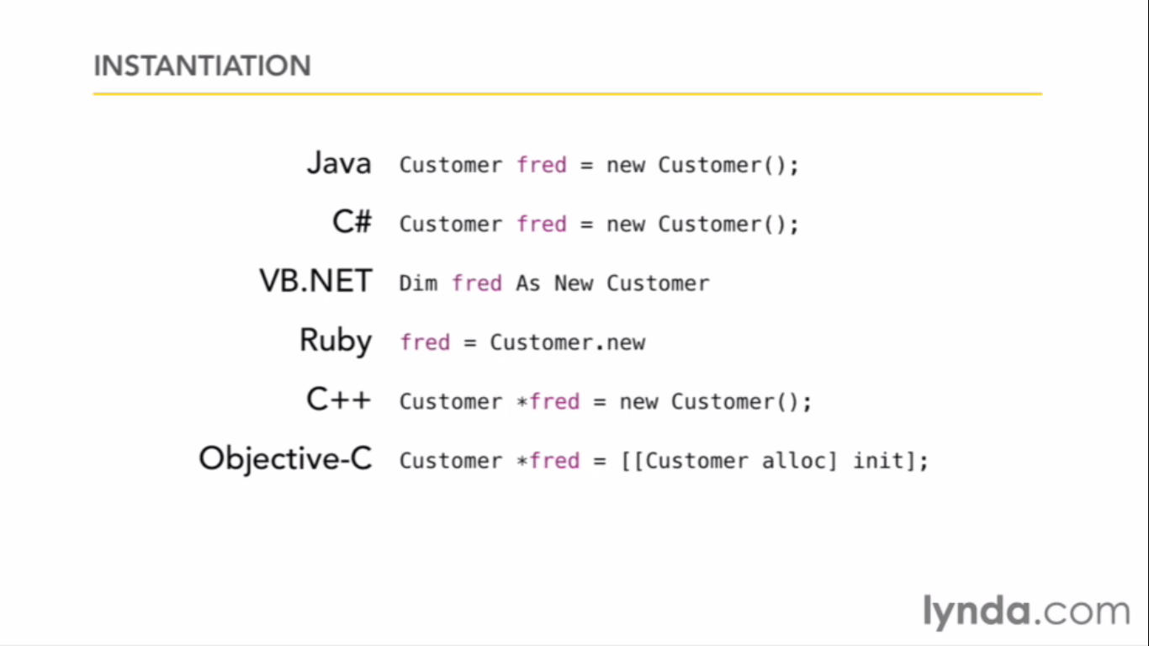

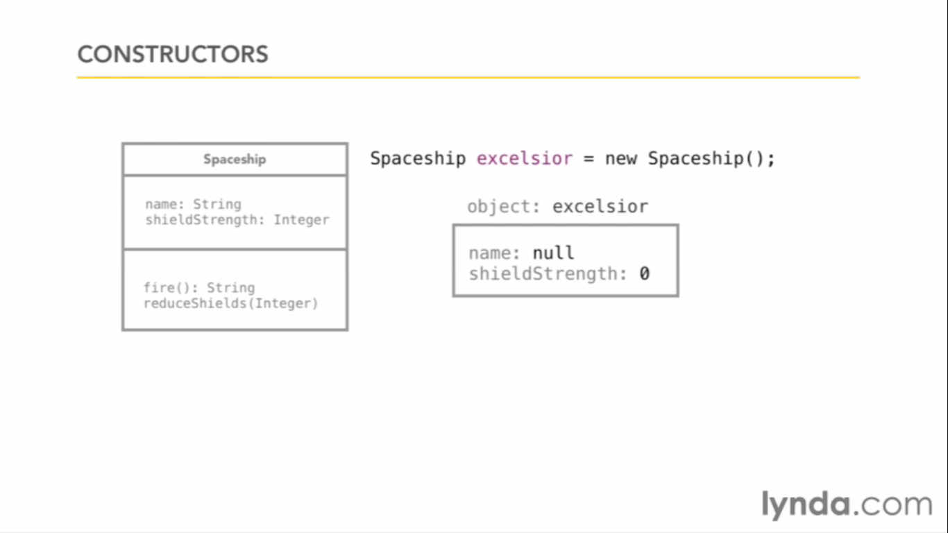

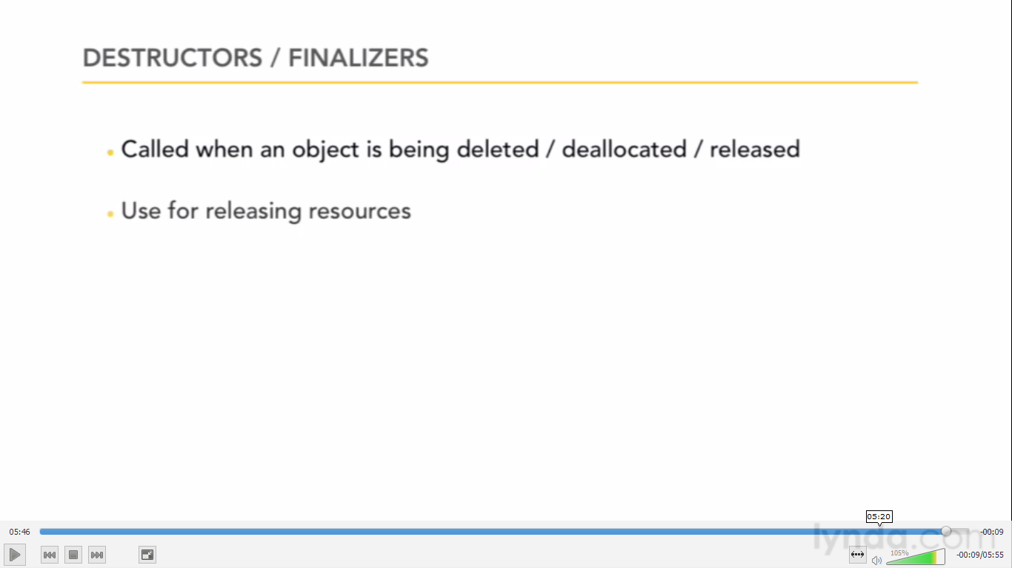

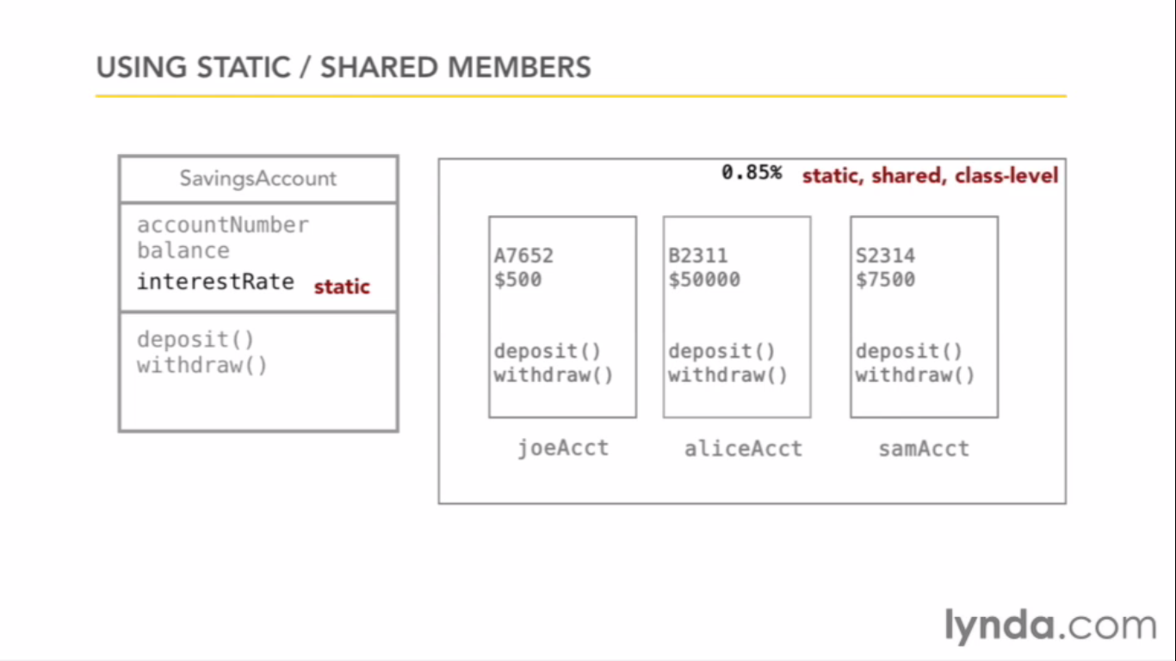

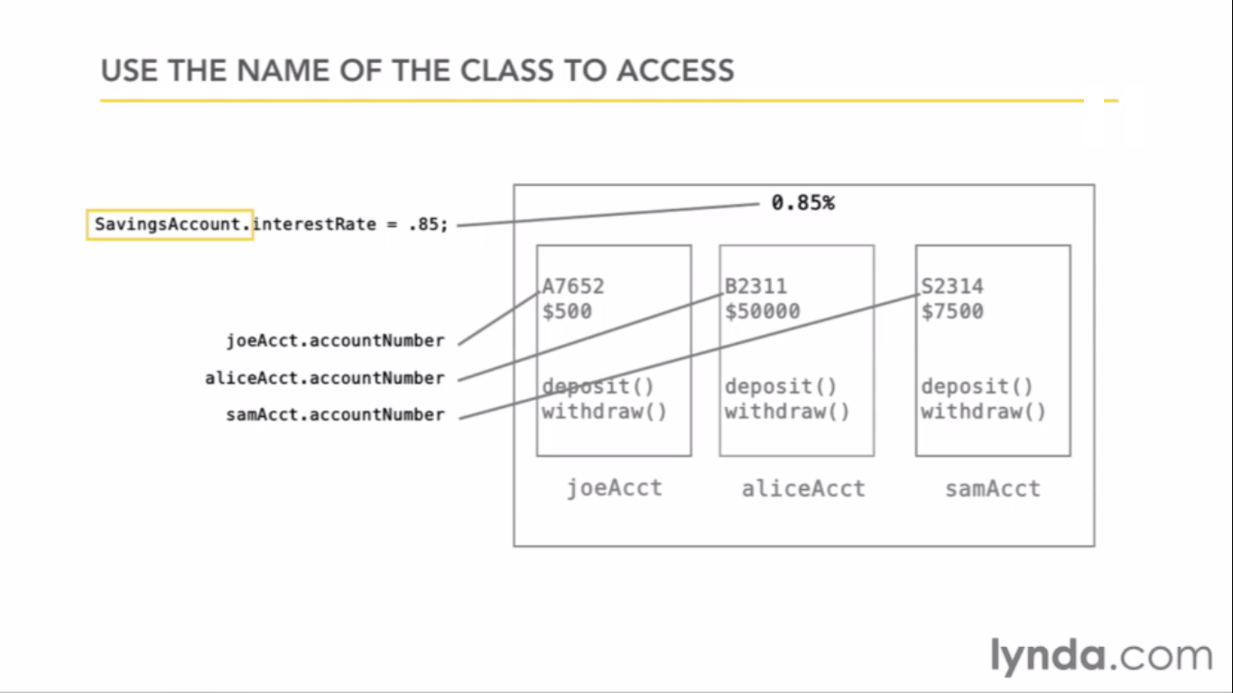

Static methods can only access Static variables.

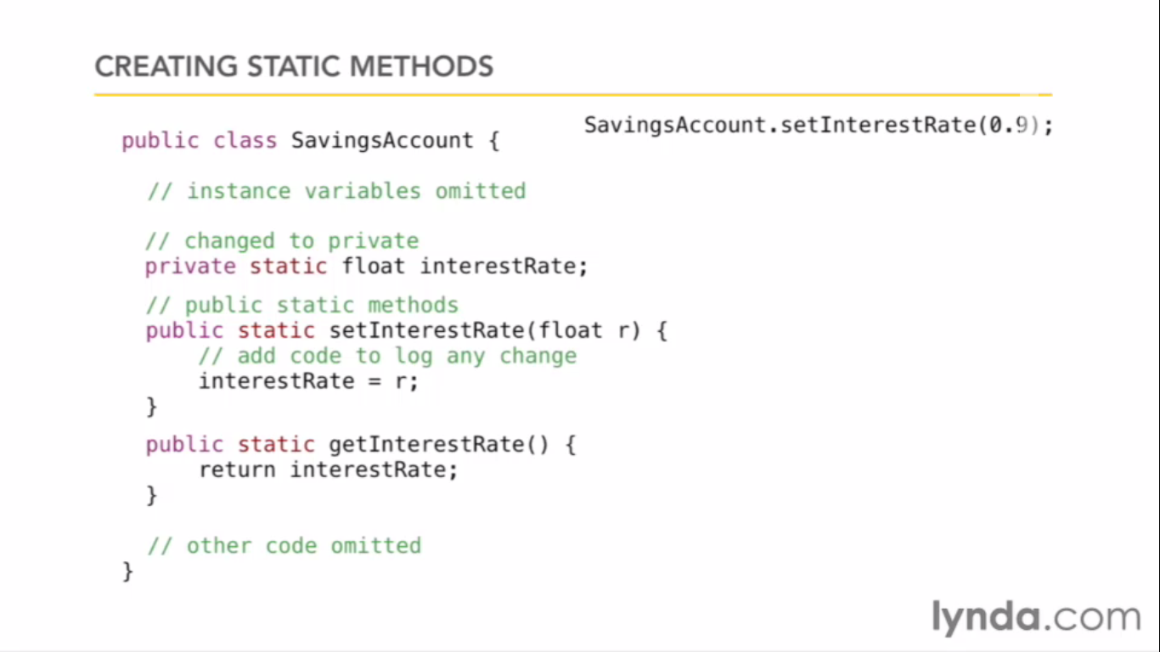

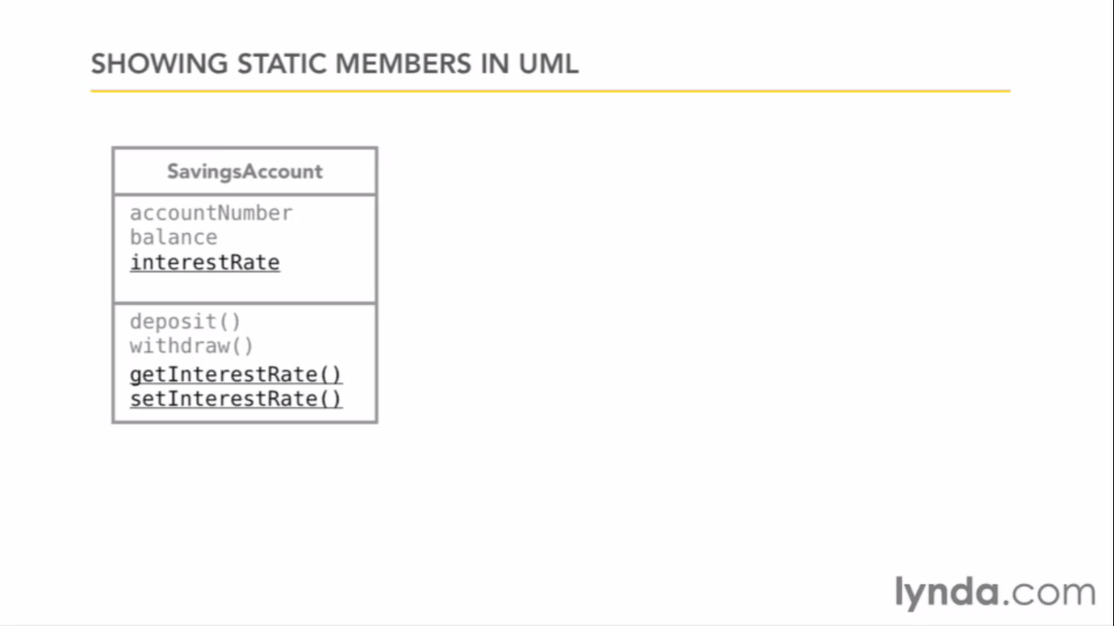

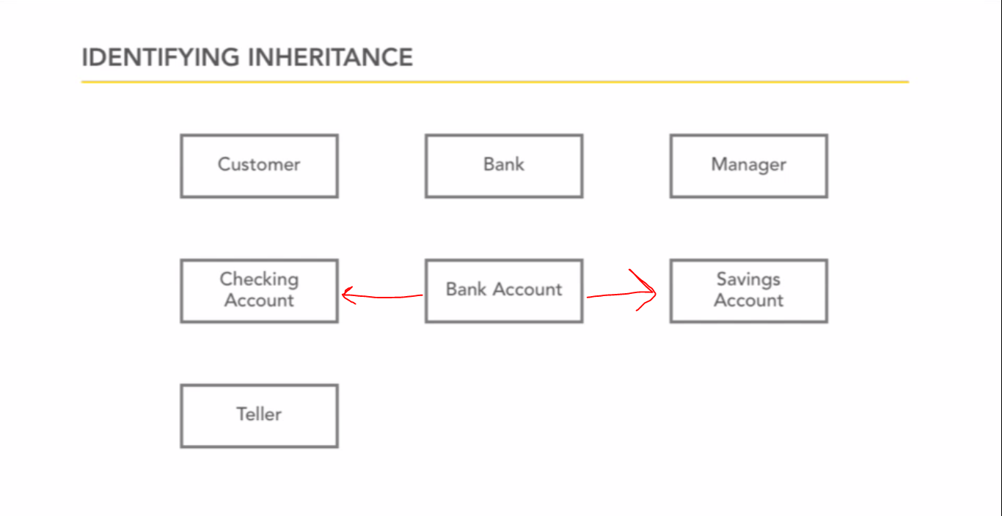

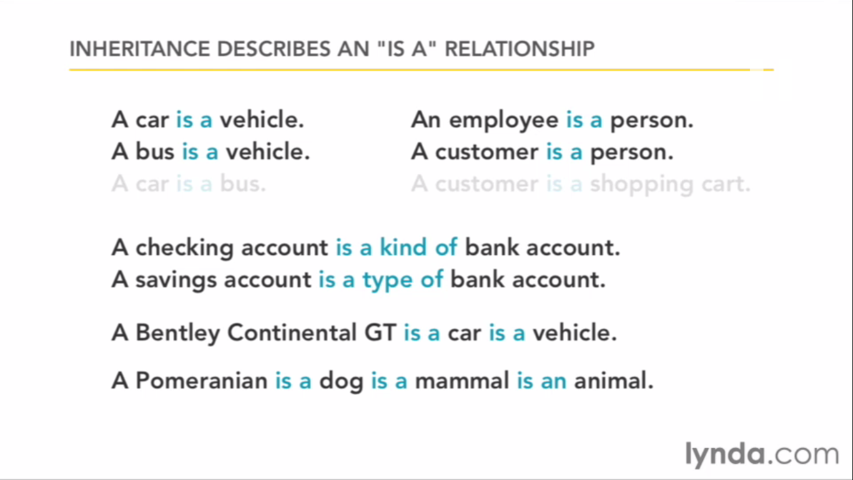

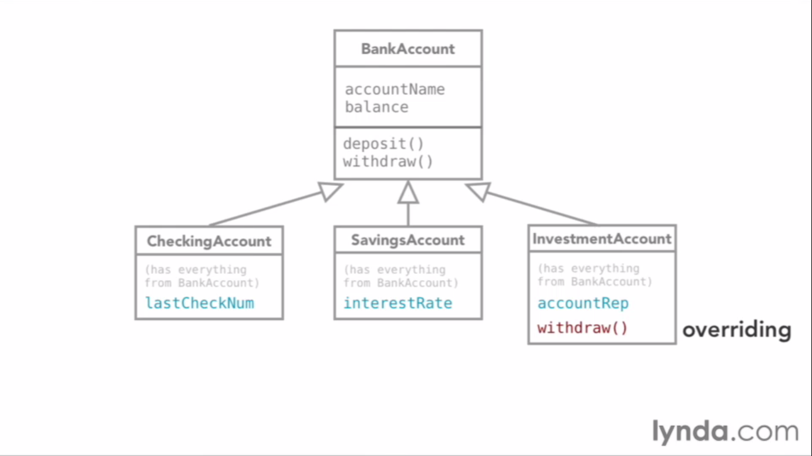

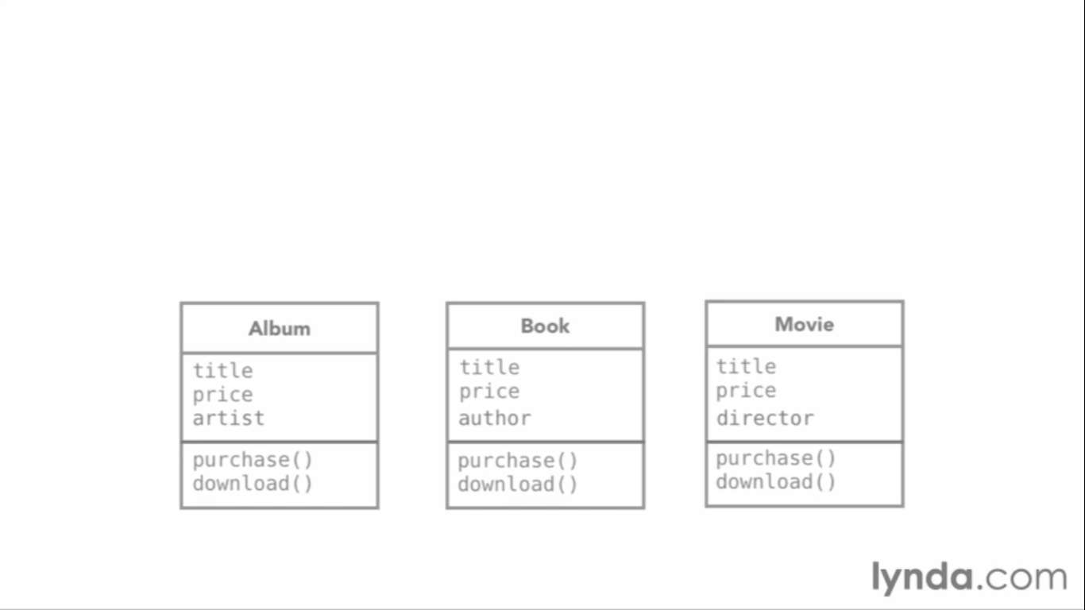

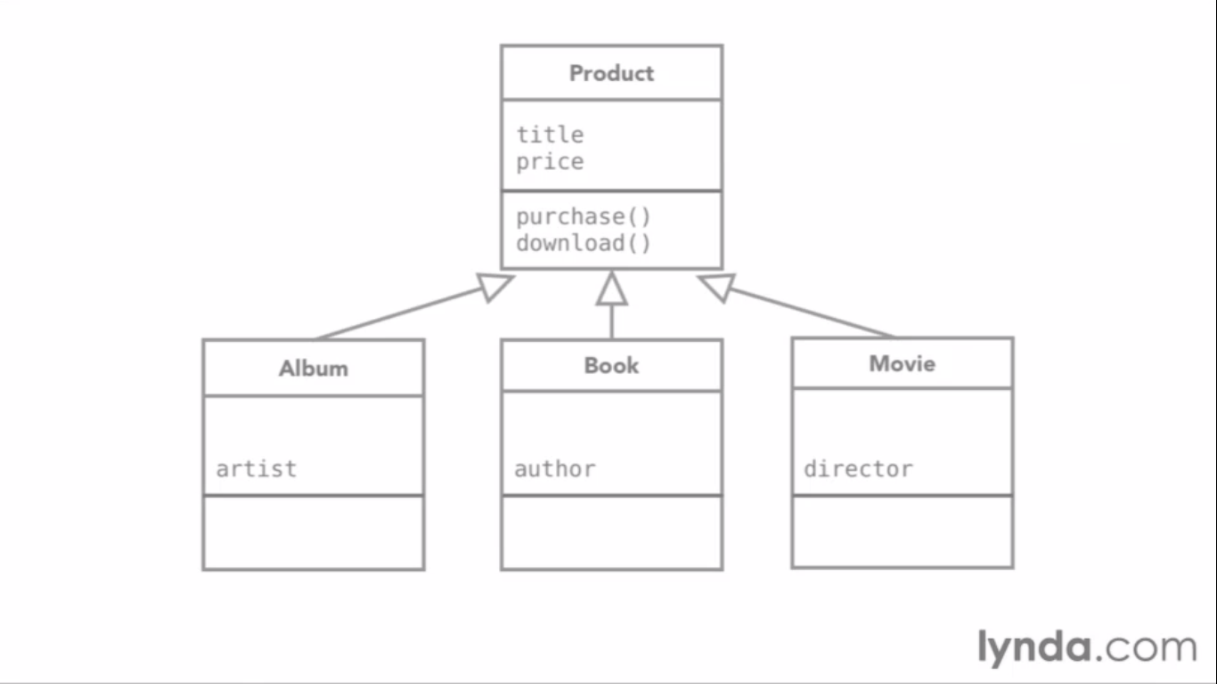

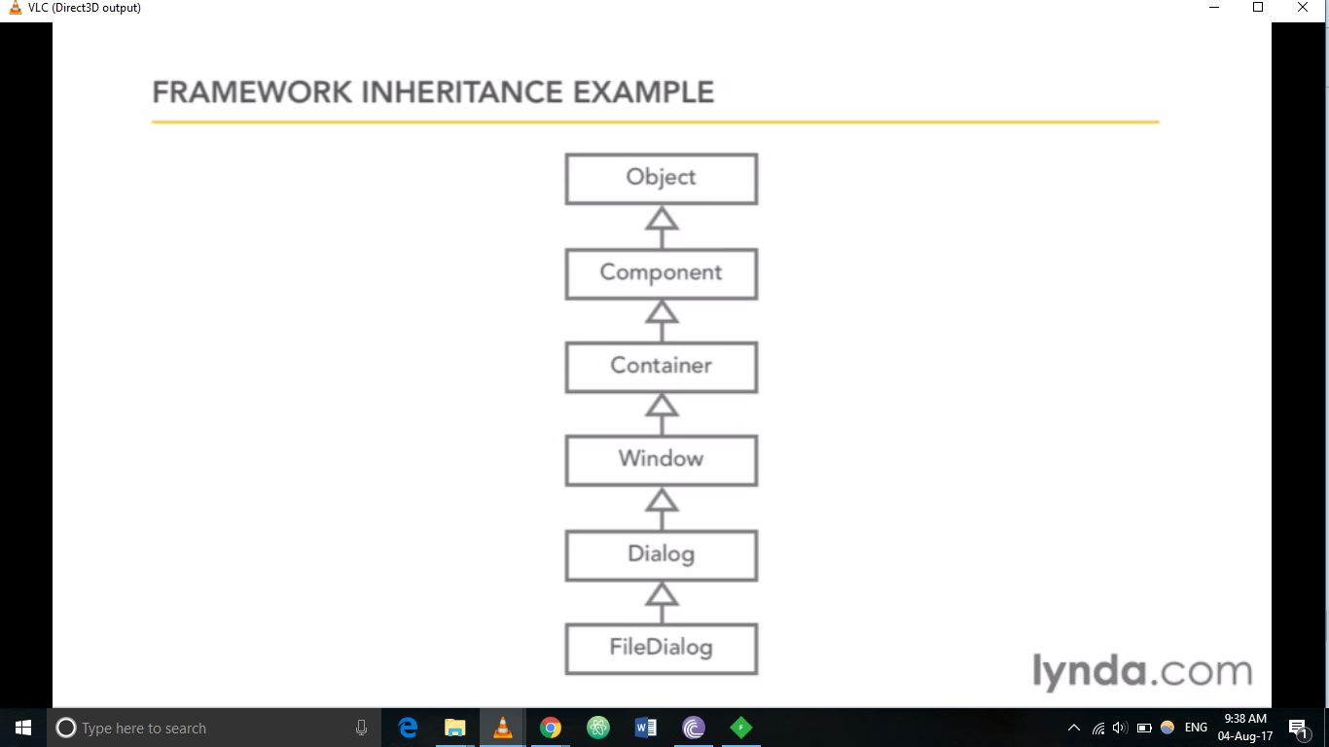

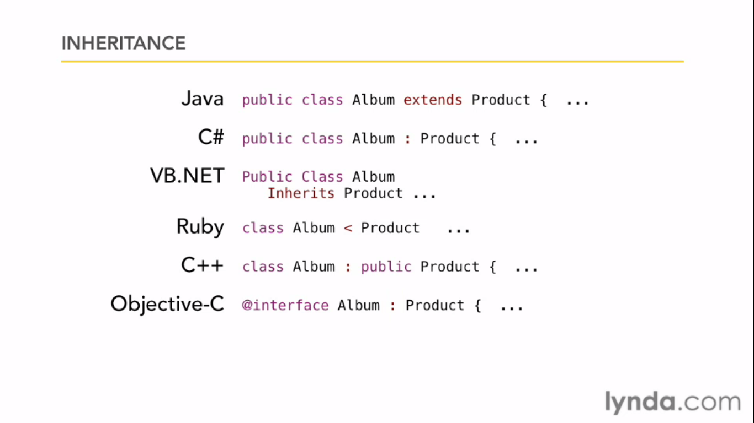

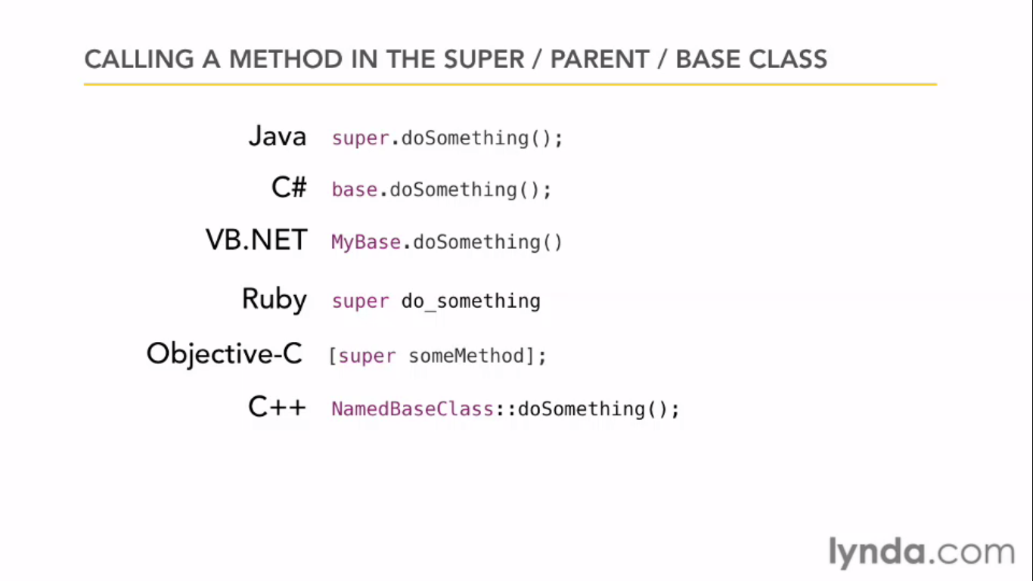

There is no abstract in ruby.

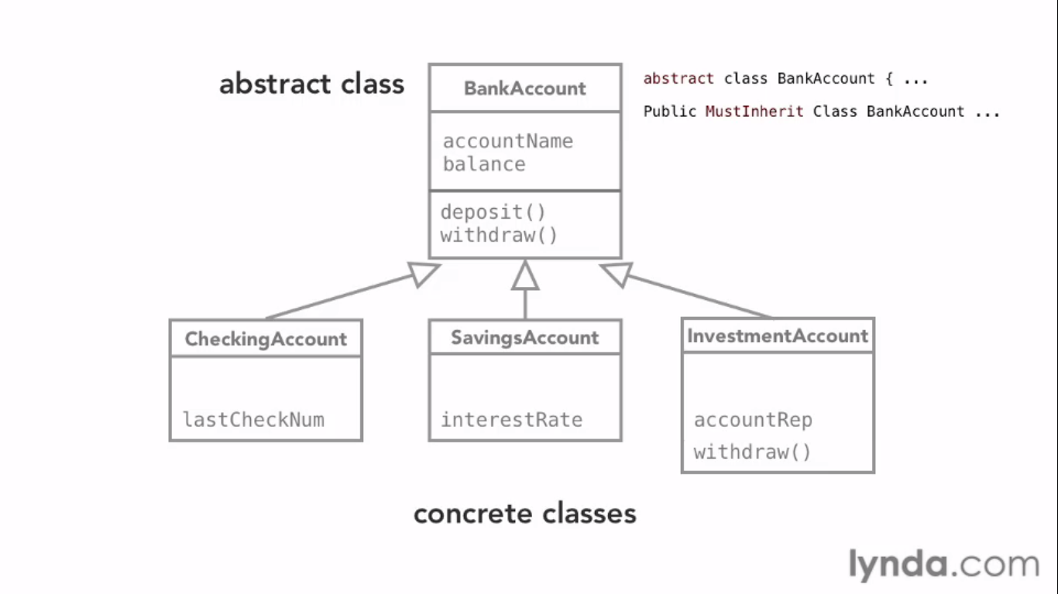

Interface

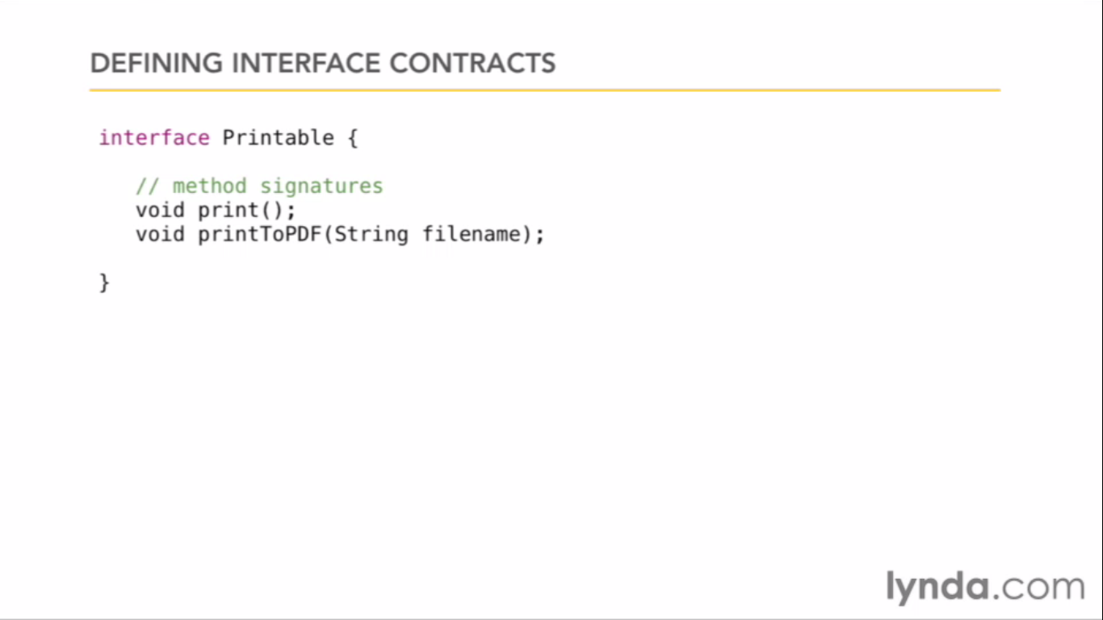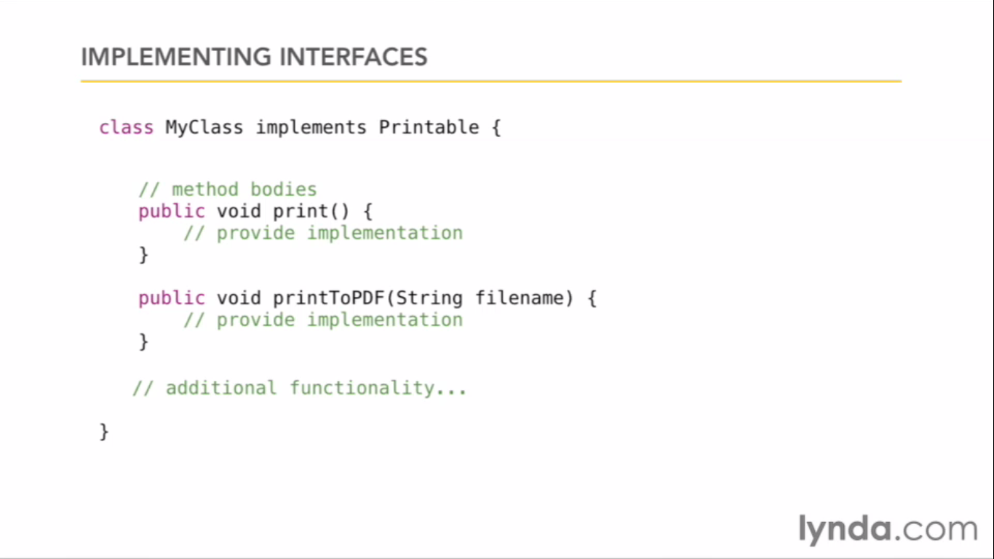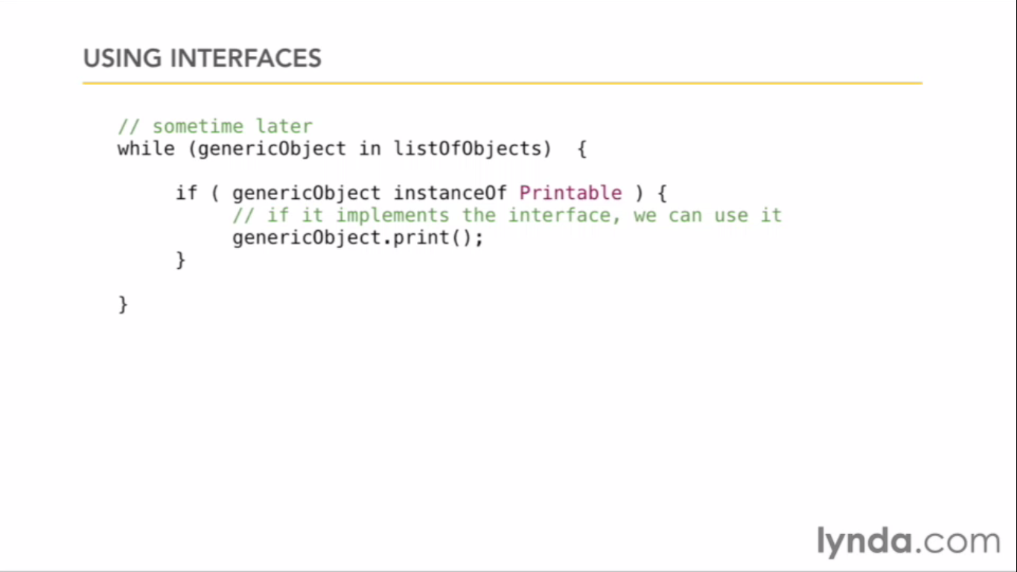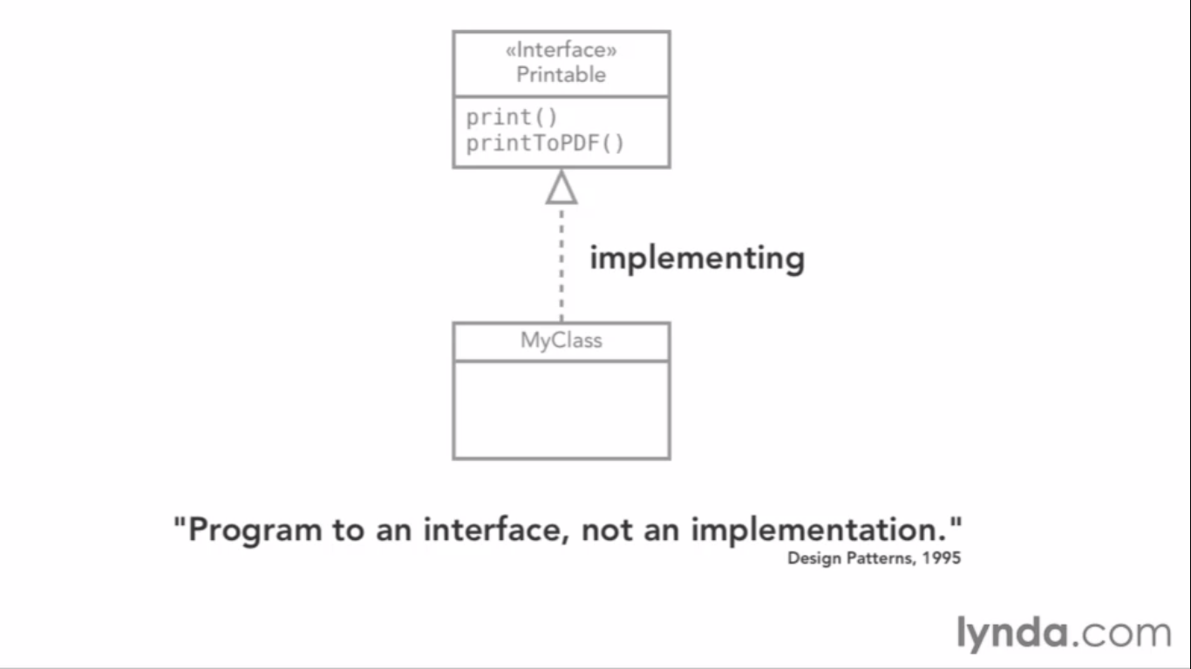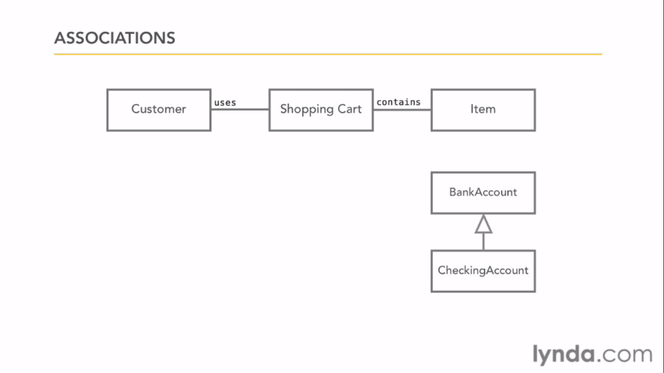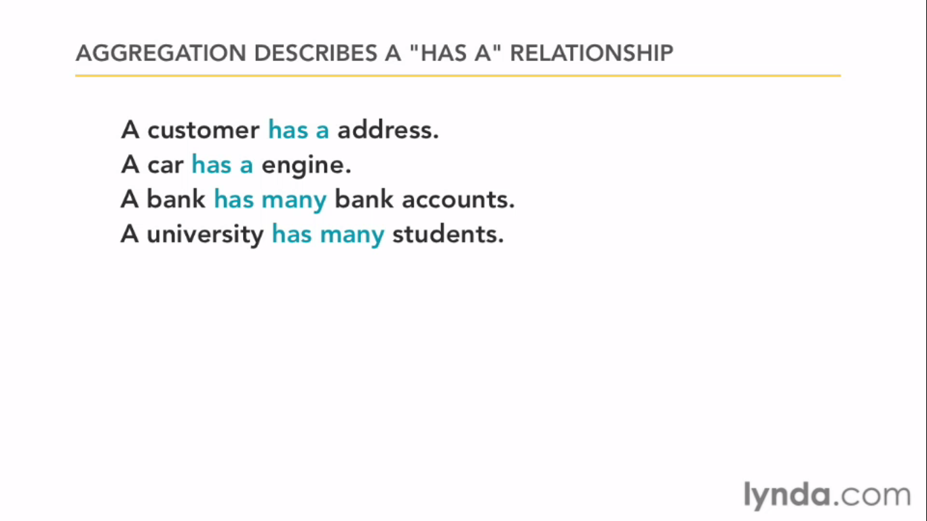

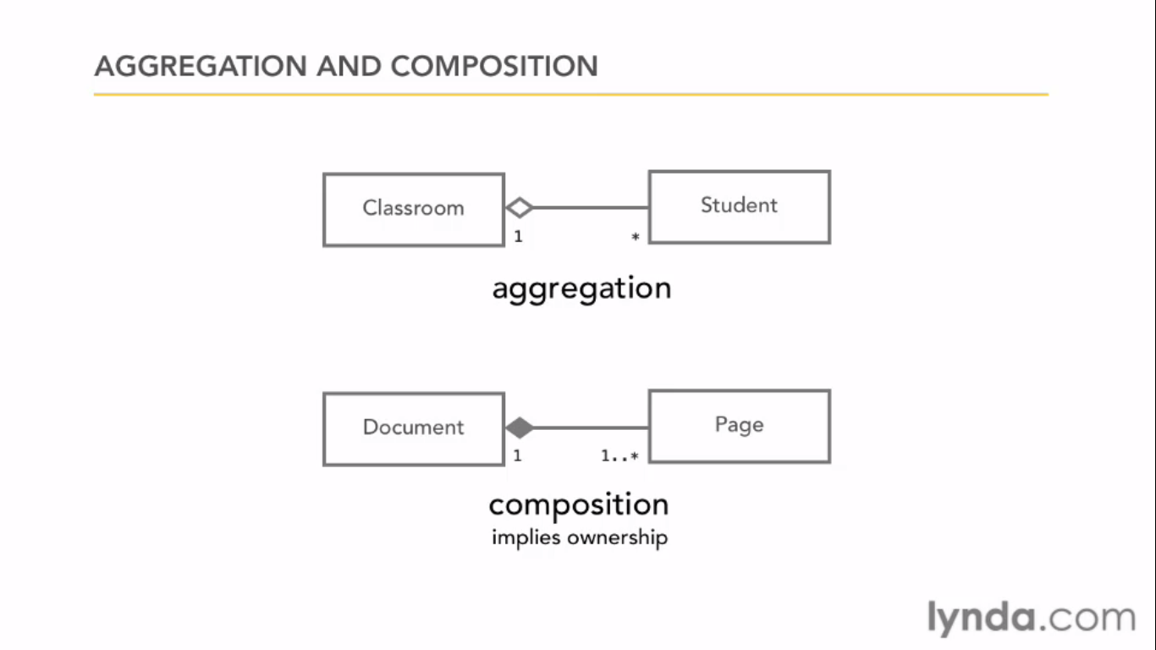

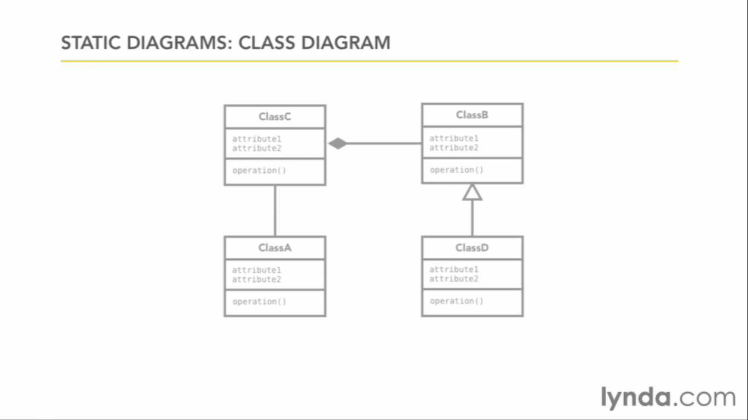

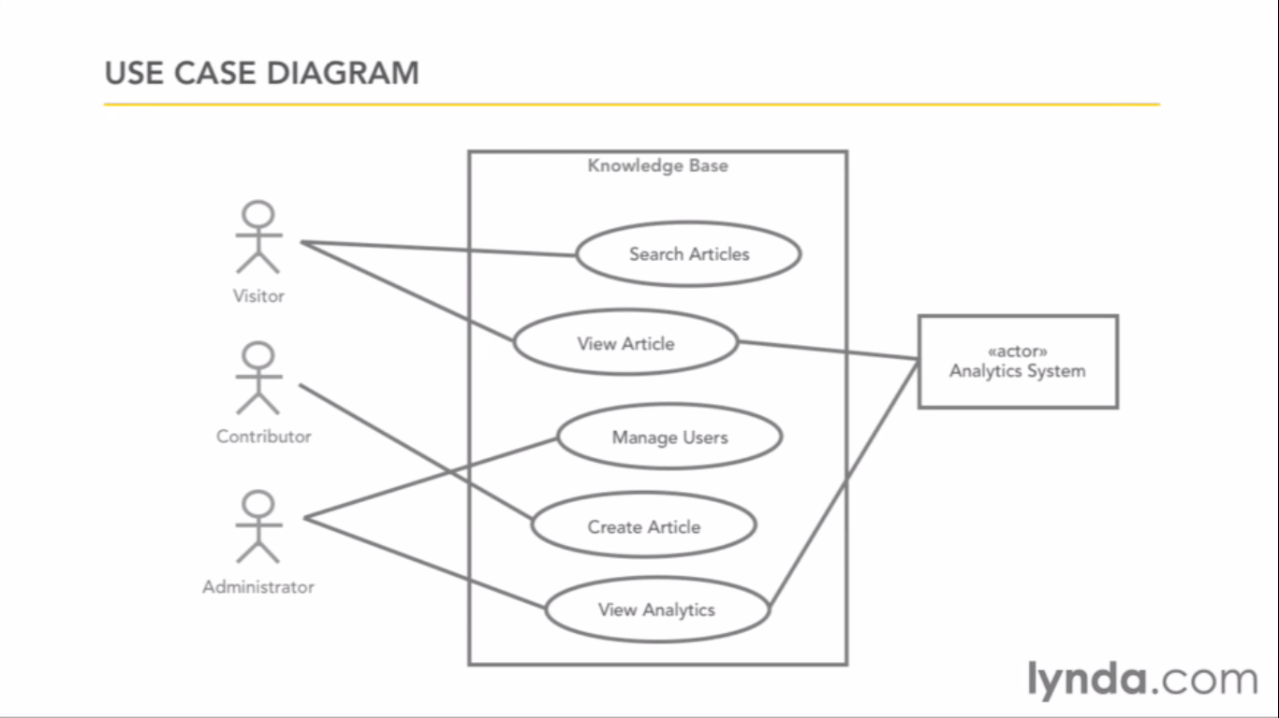

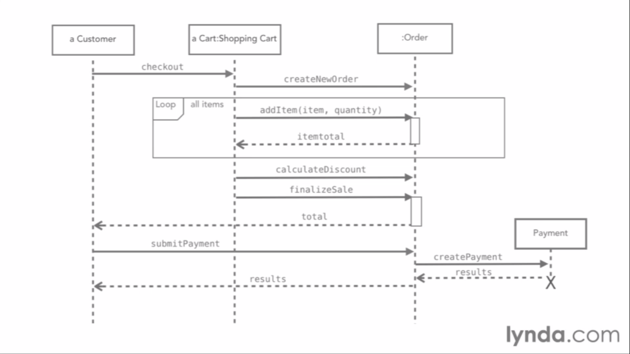

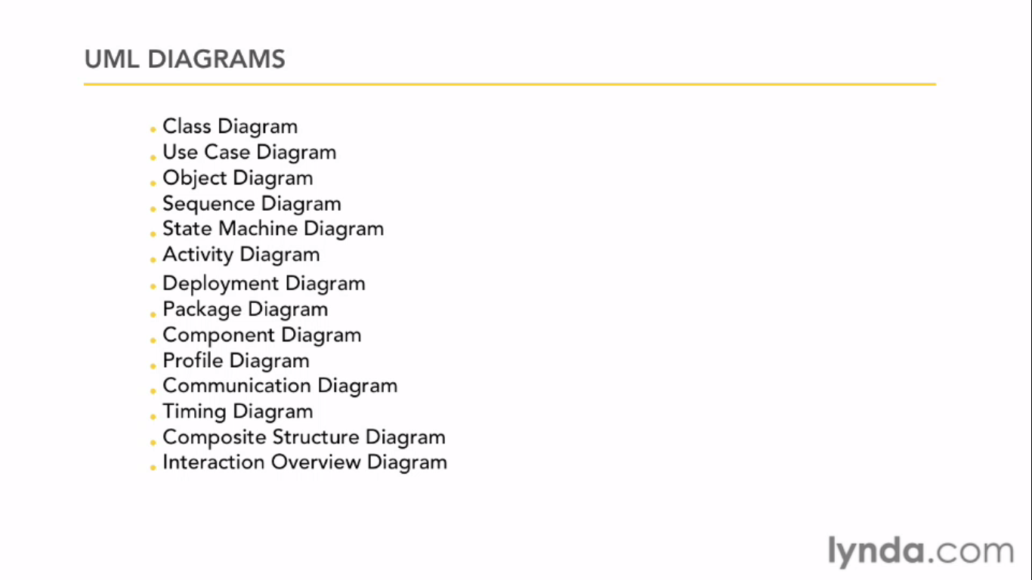

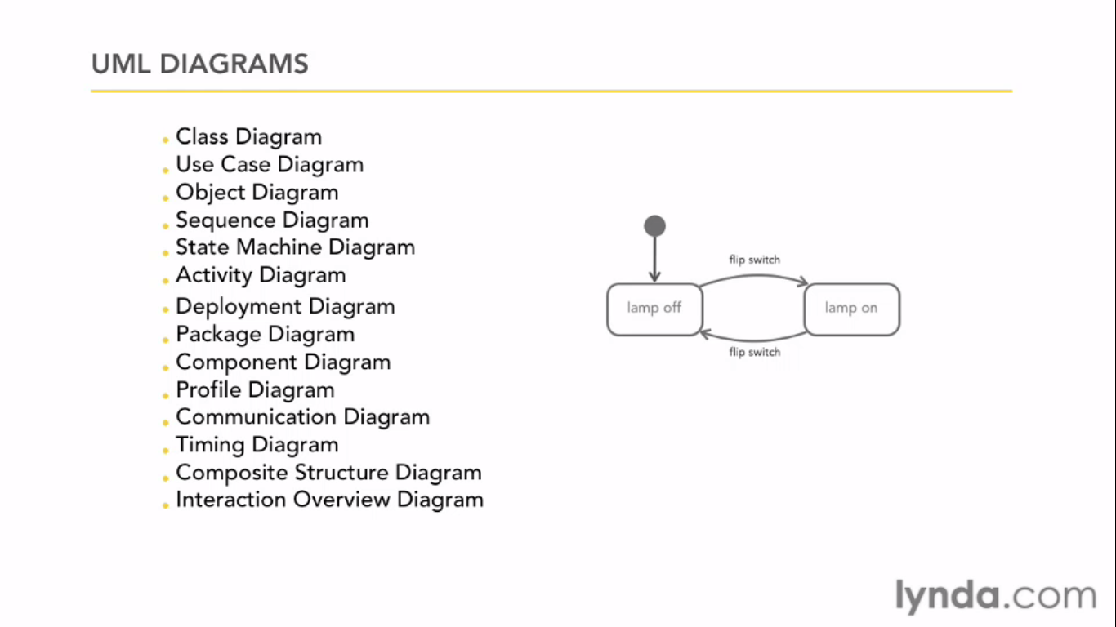

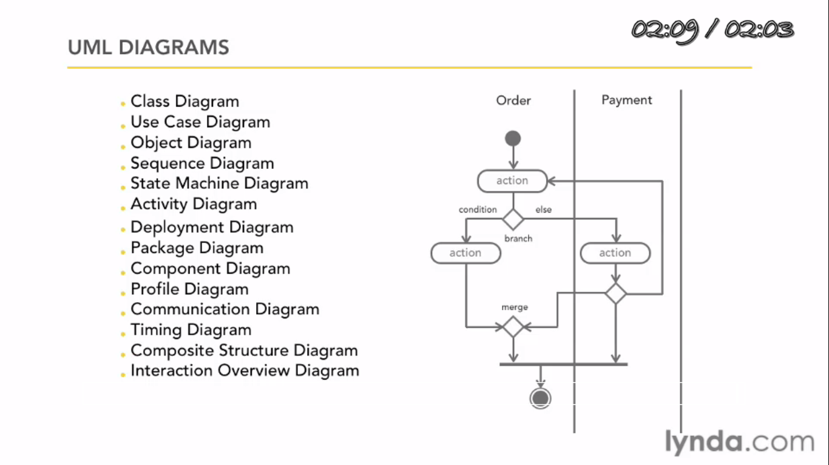

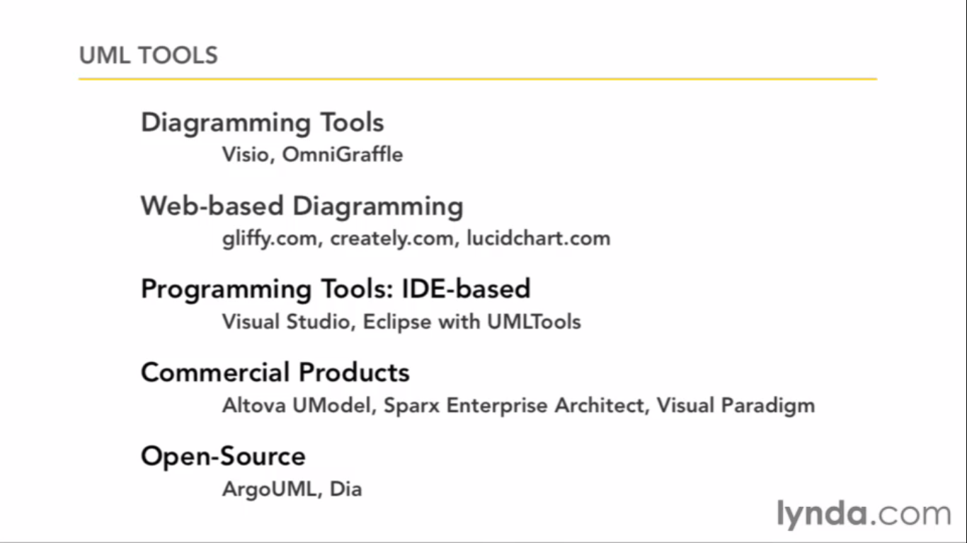

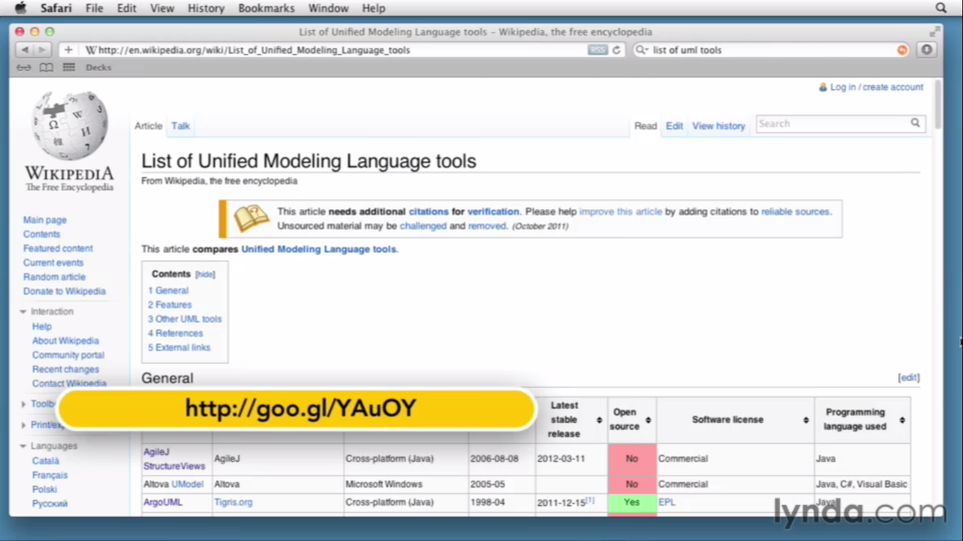

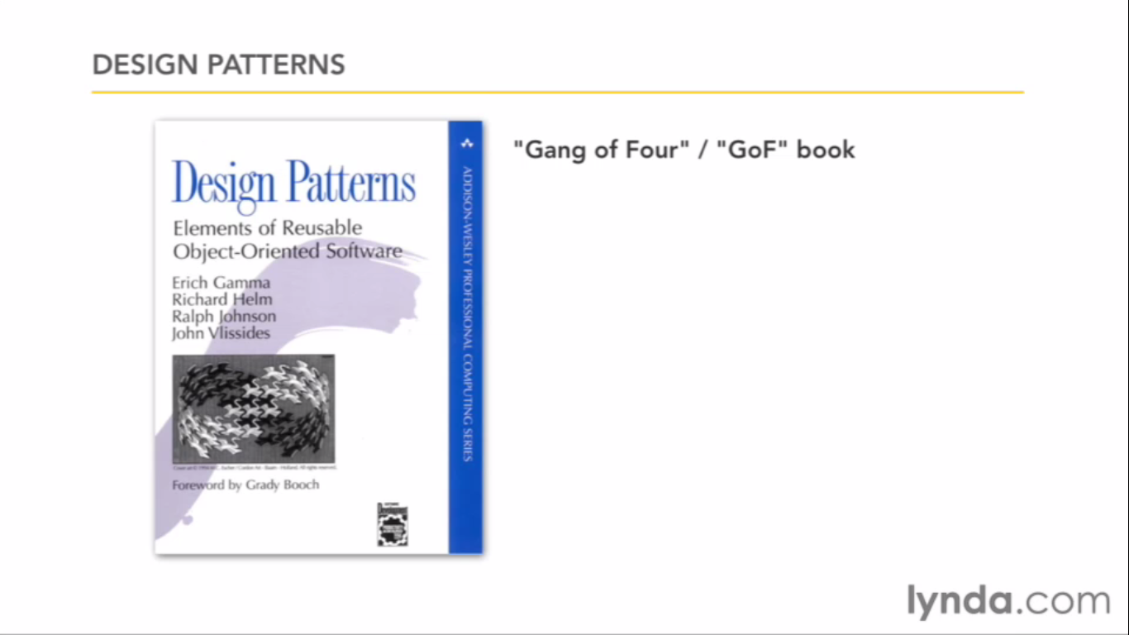

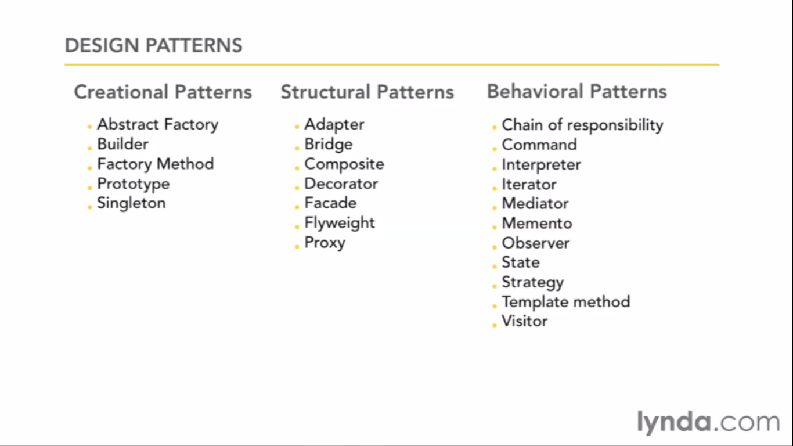

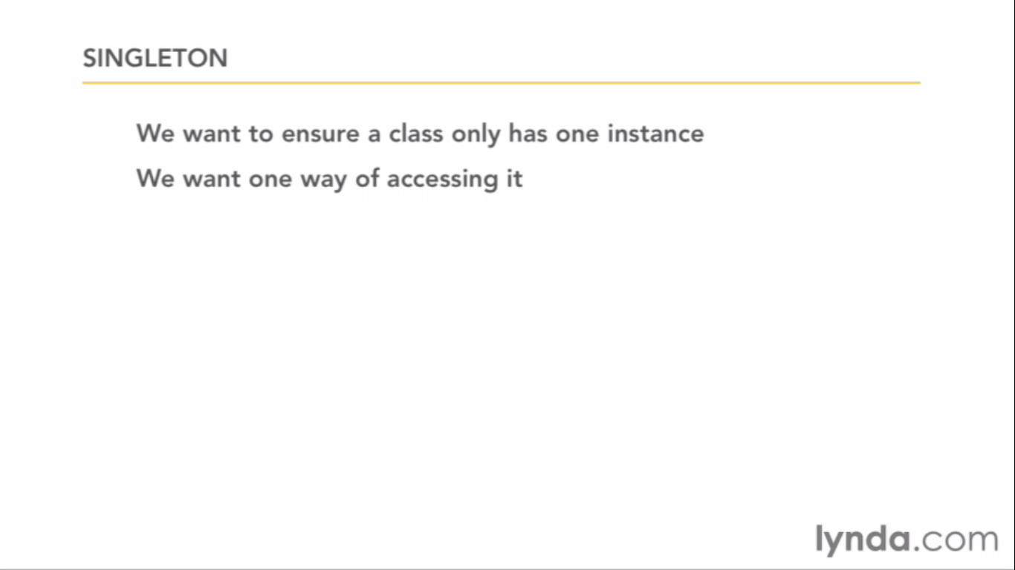

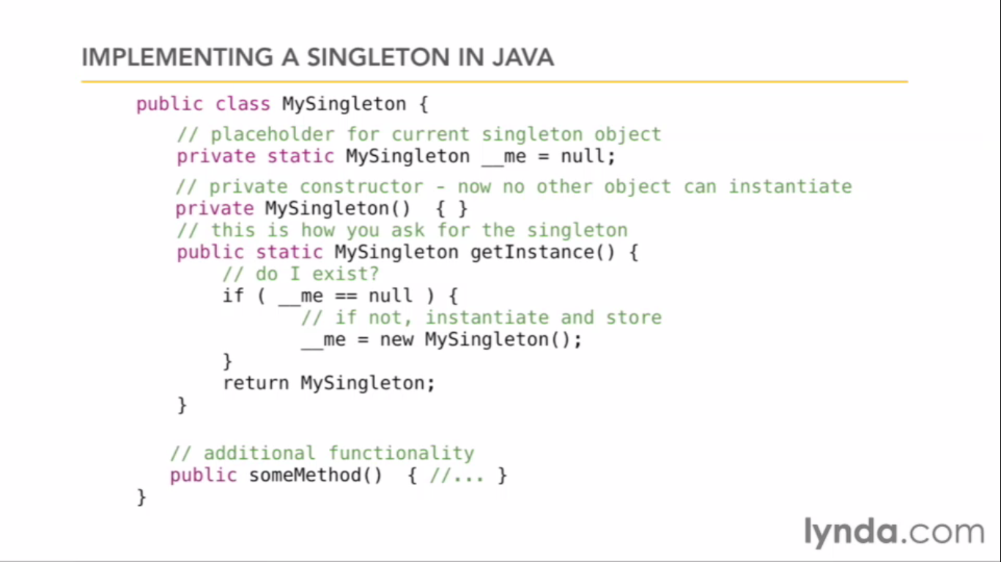

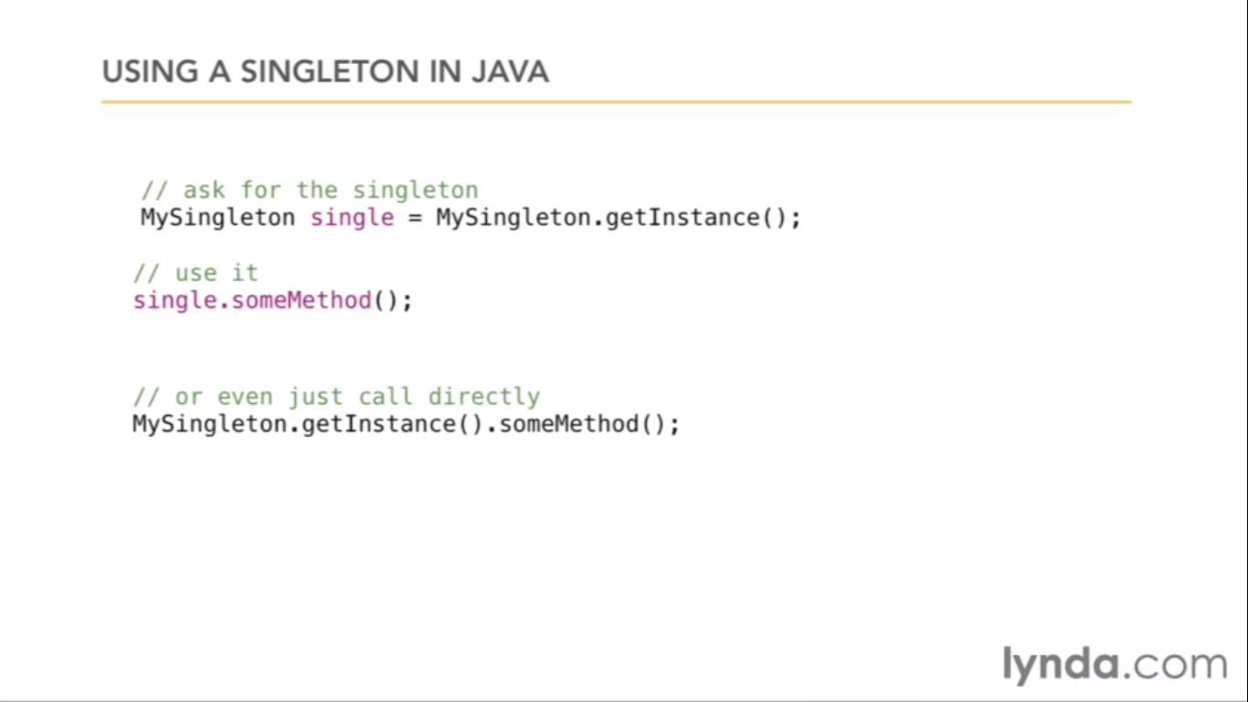

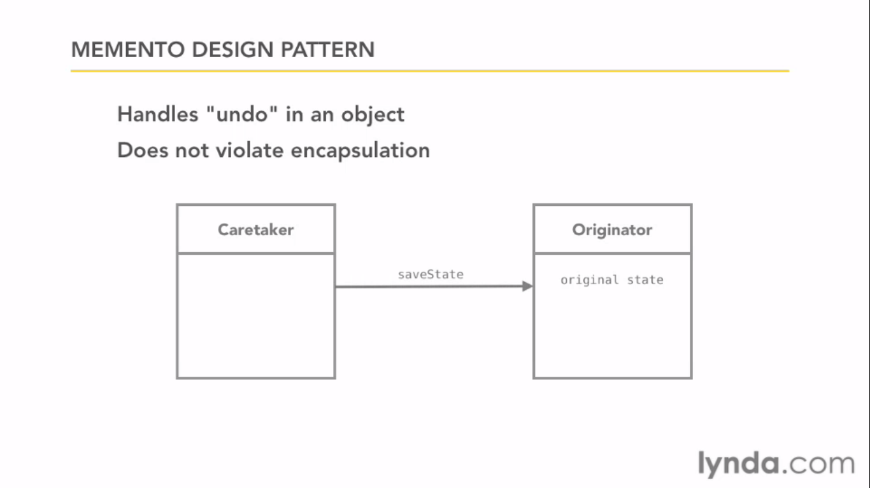



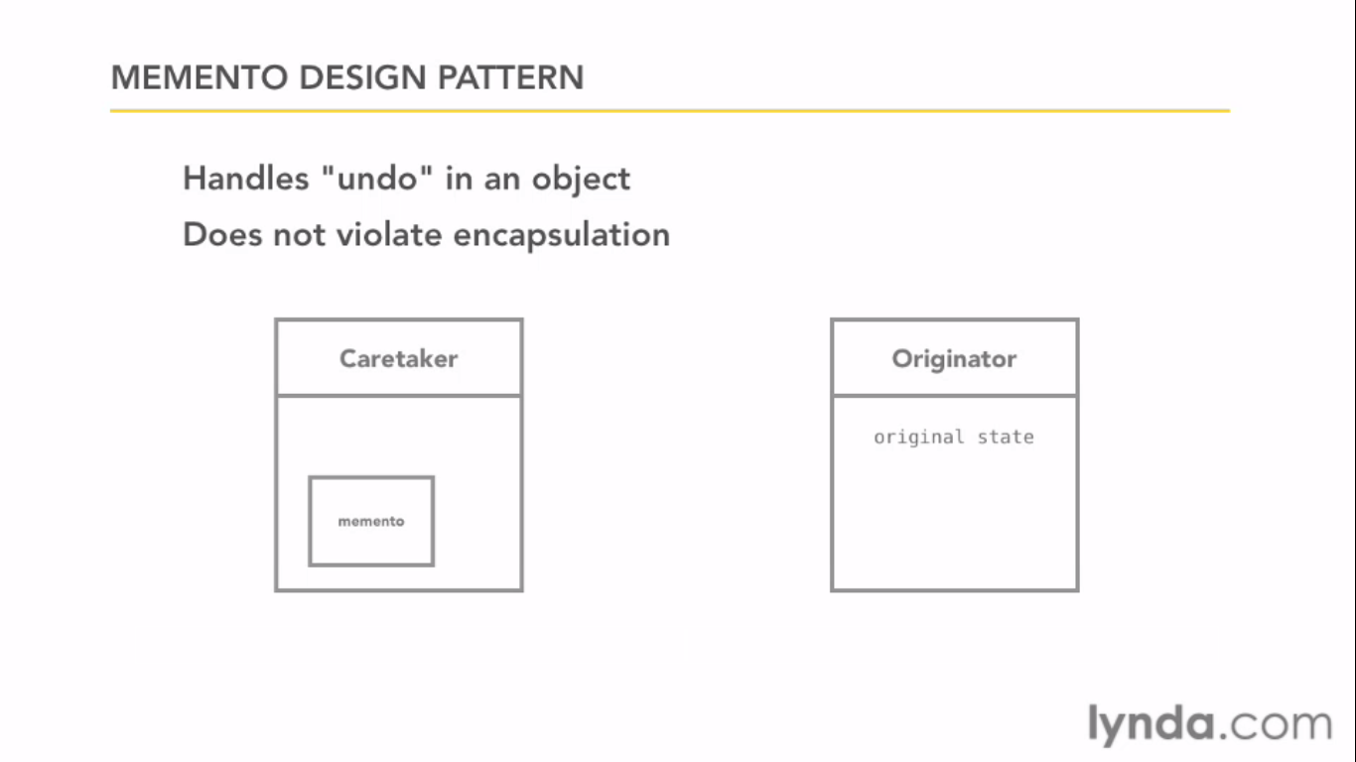

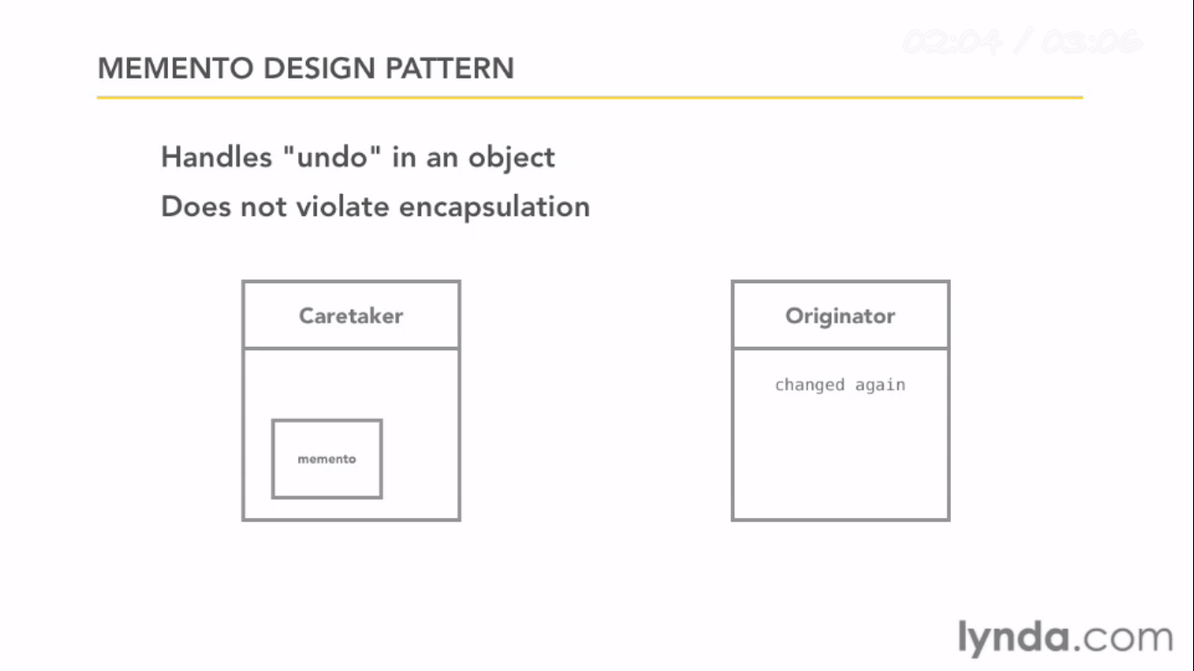

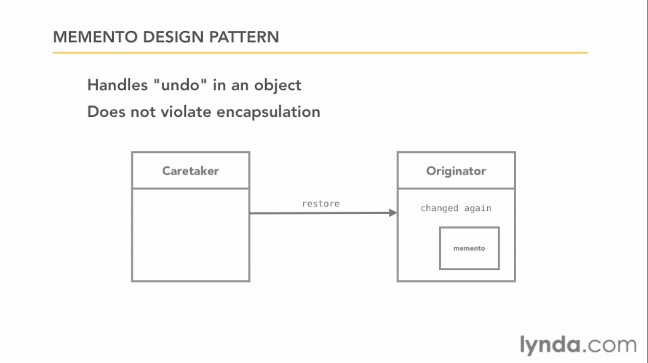

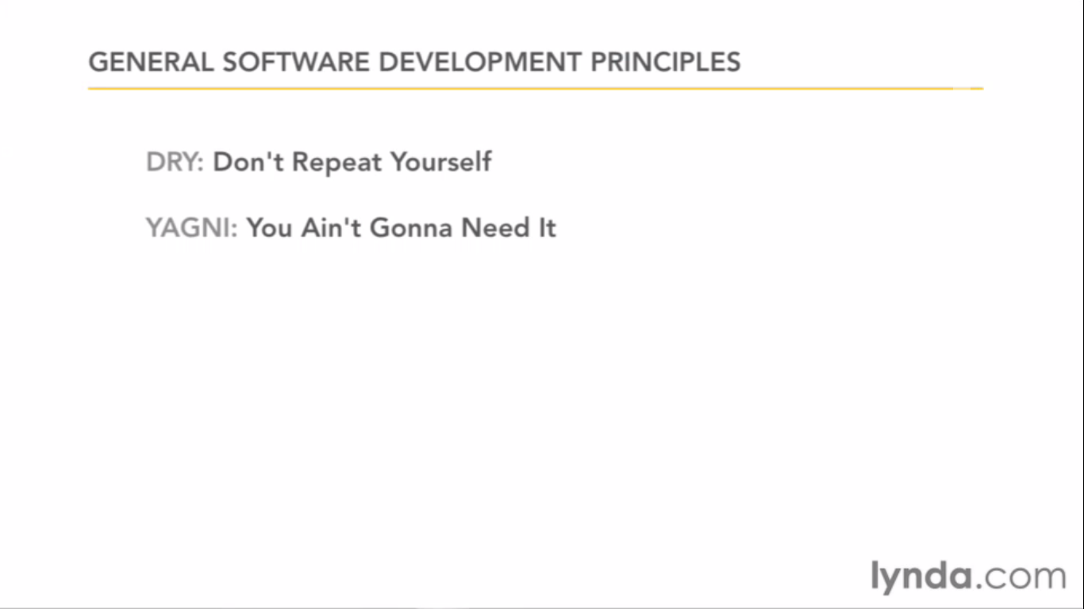

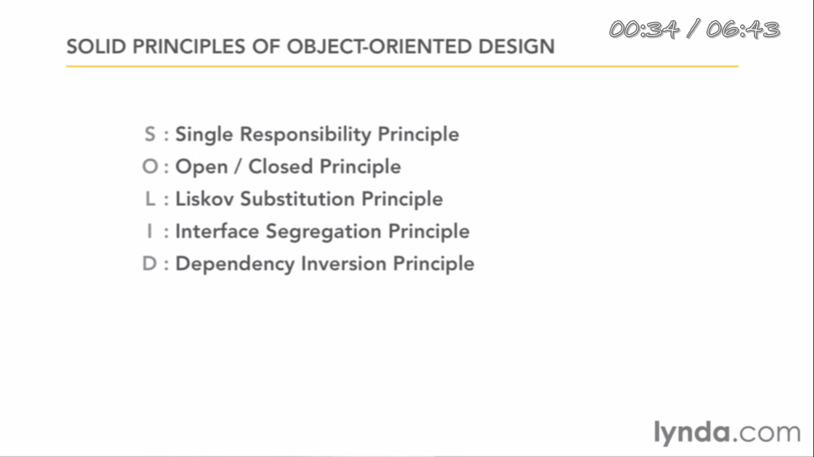

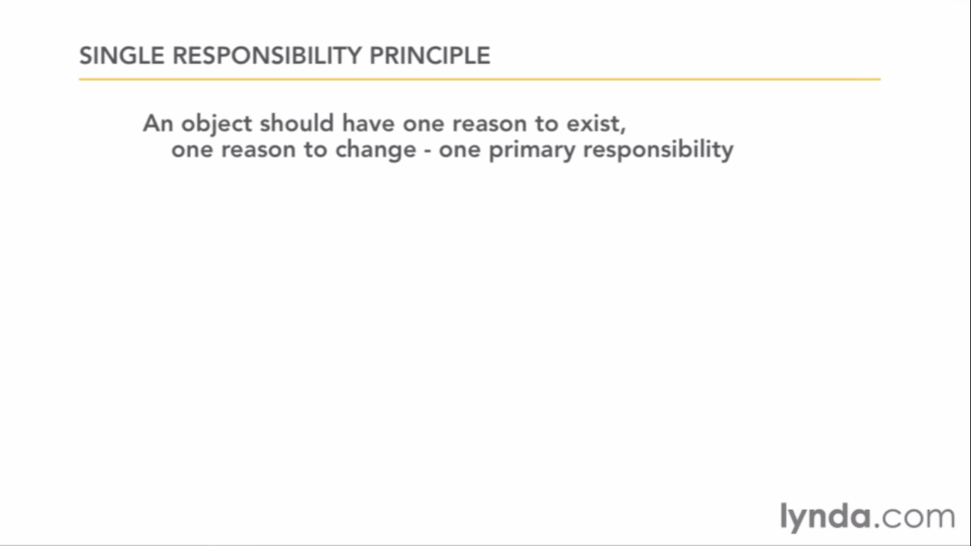

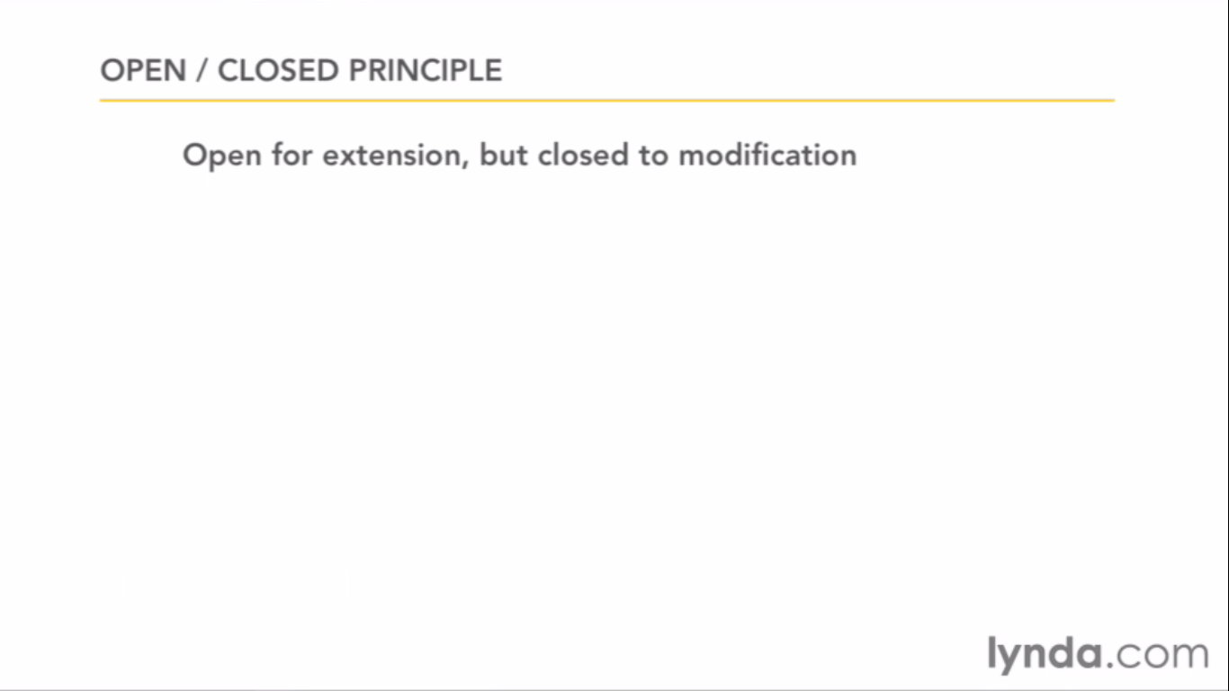

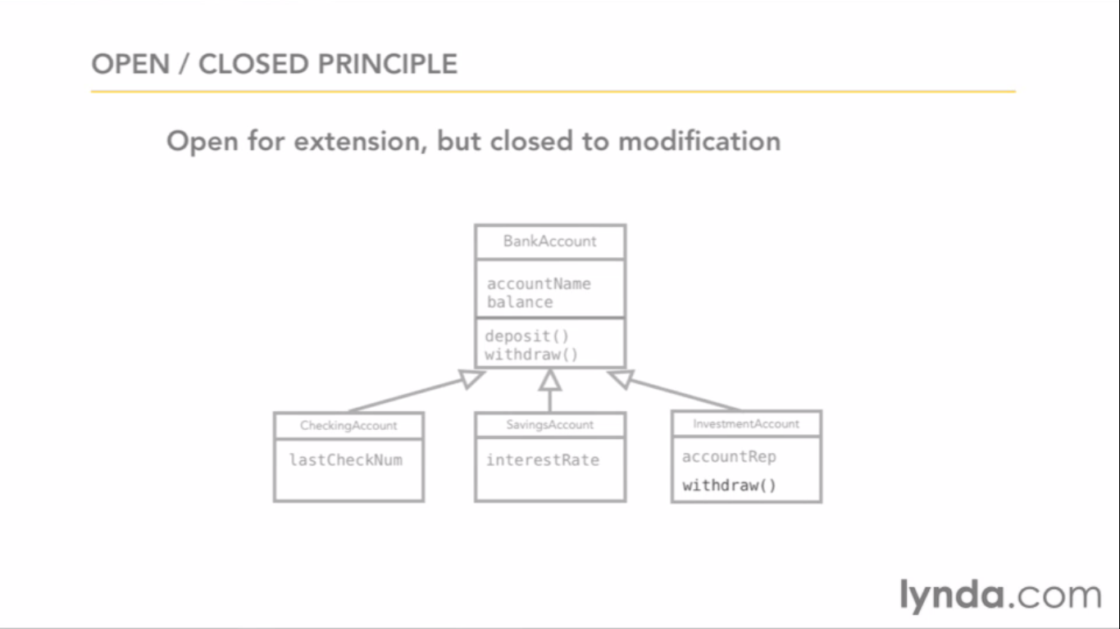

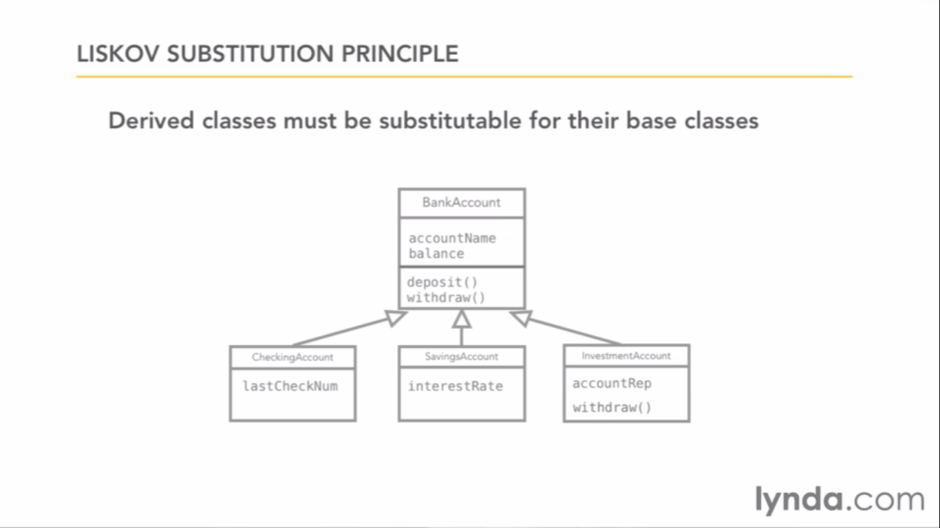

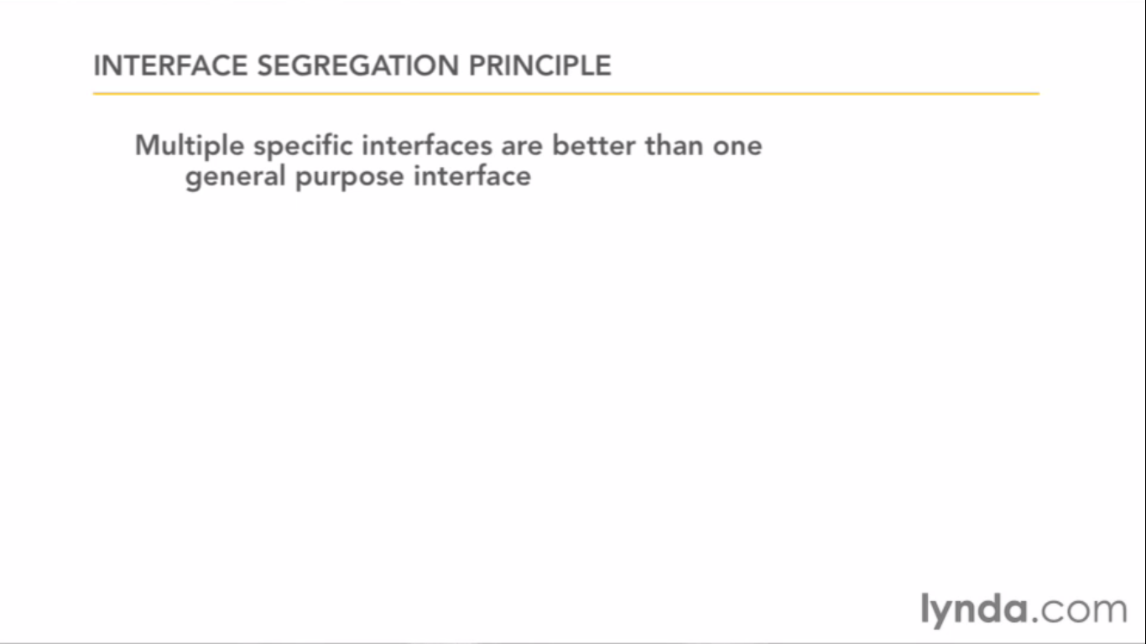

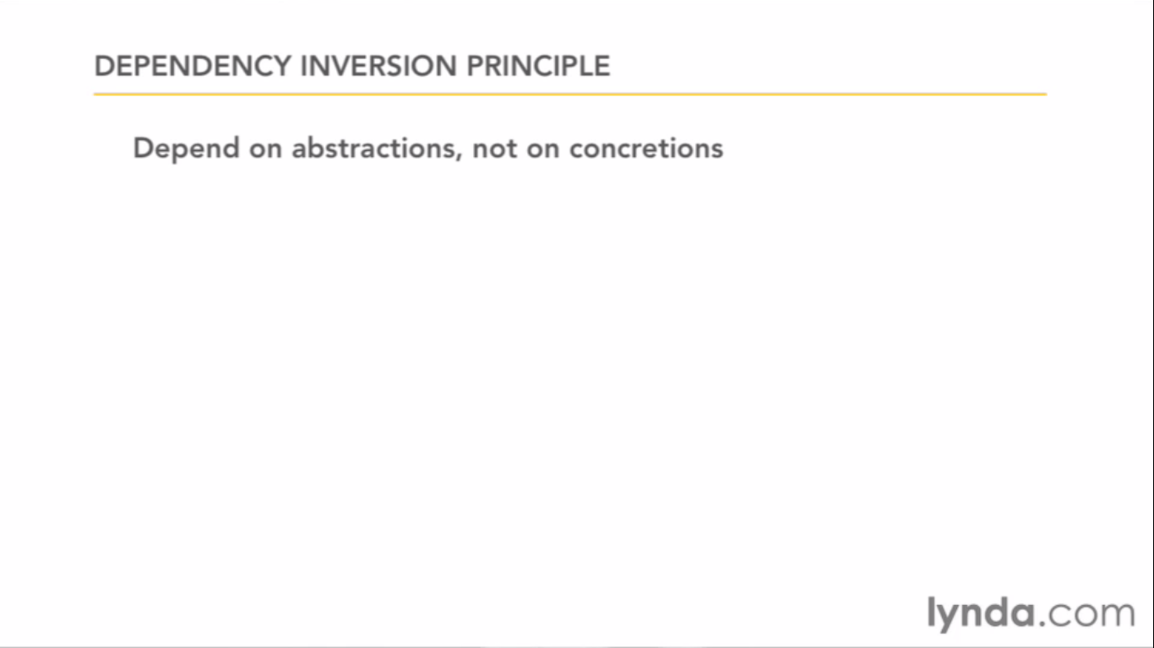

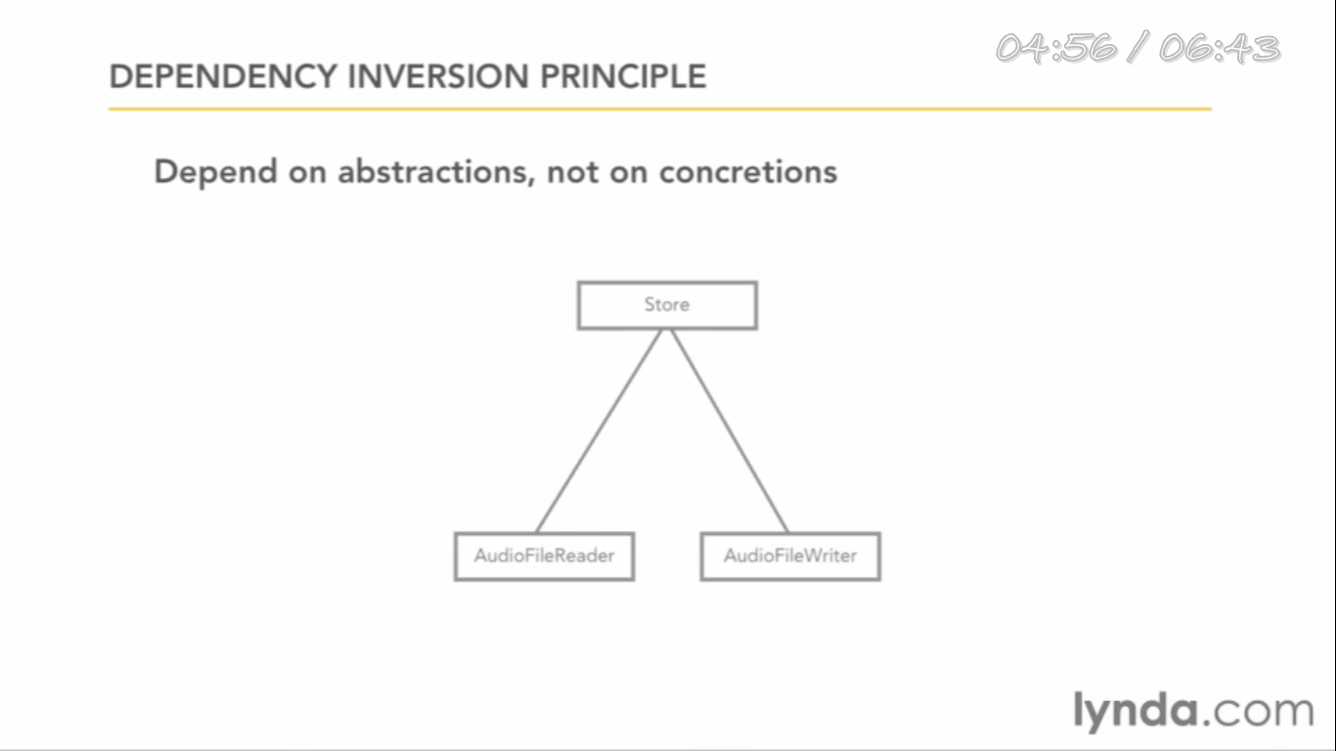

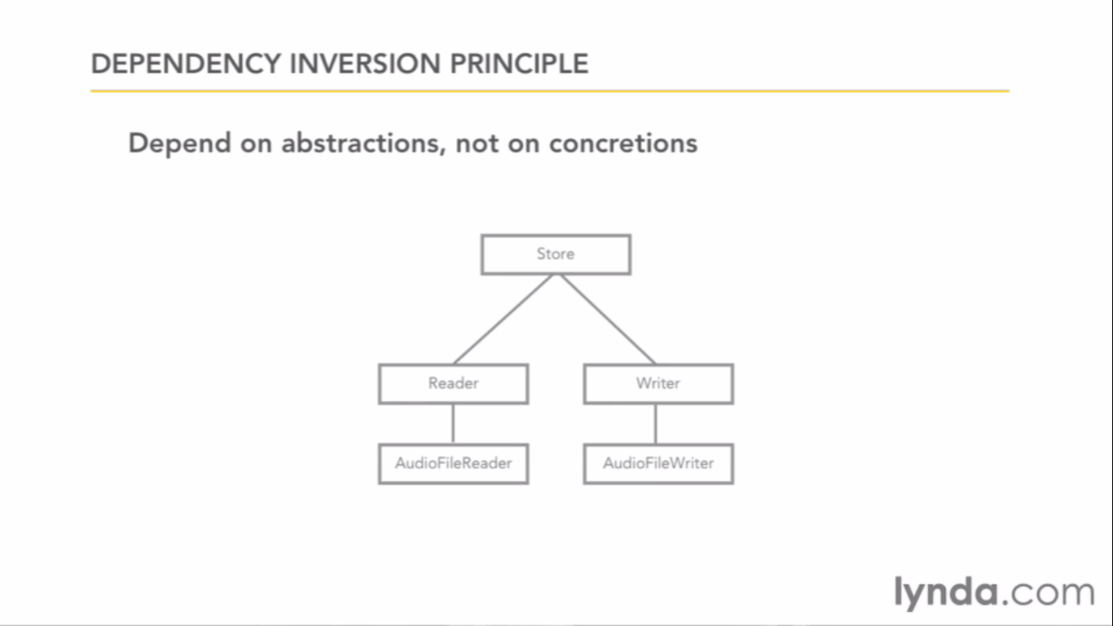

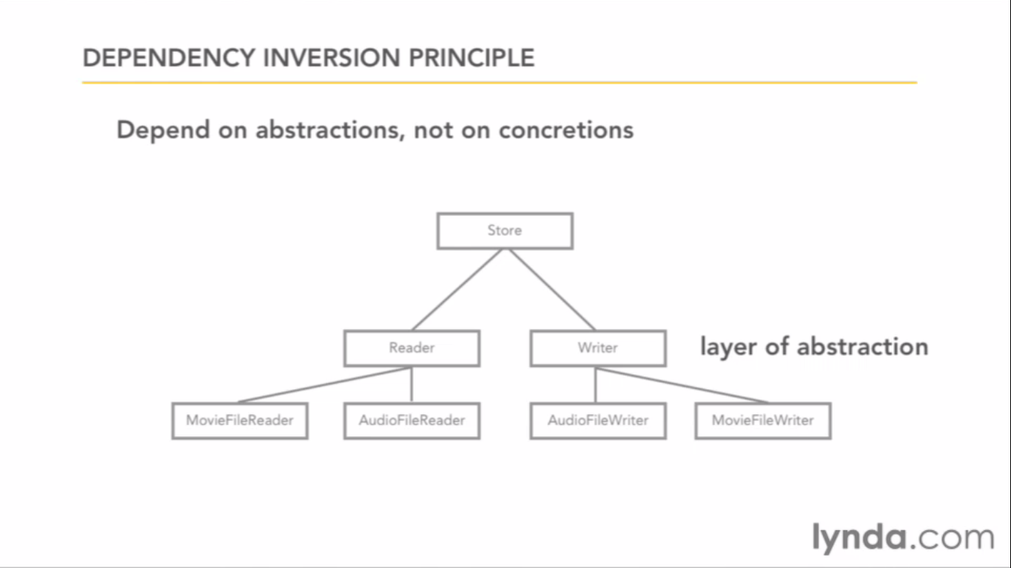

GRASP

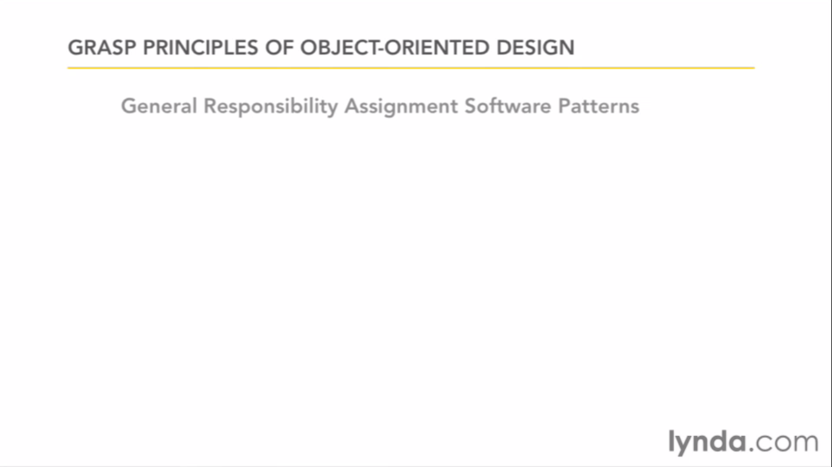

It is responsibility focused like who created this object.

Solid and grasp don’t conflict each other.

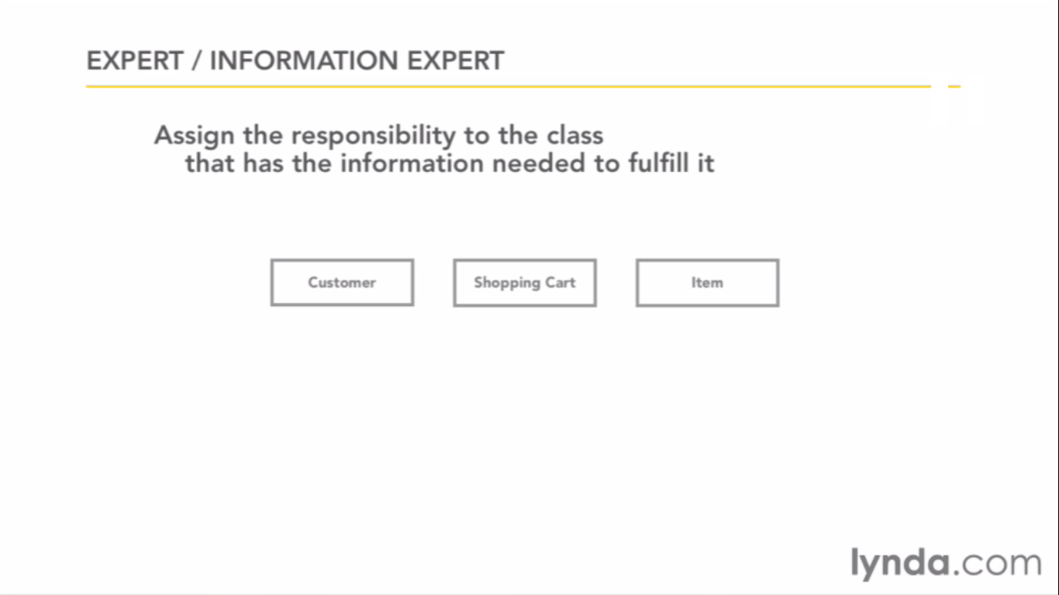

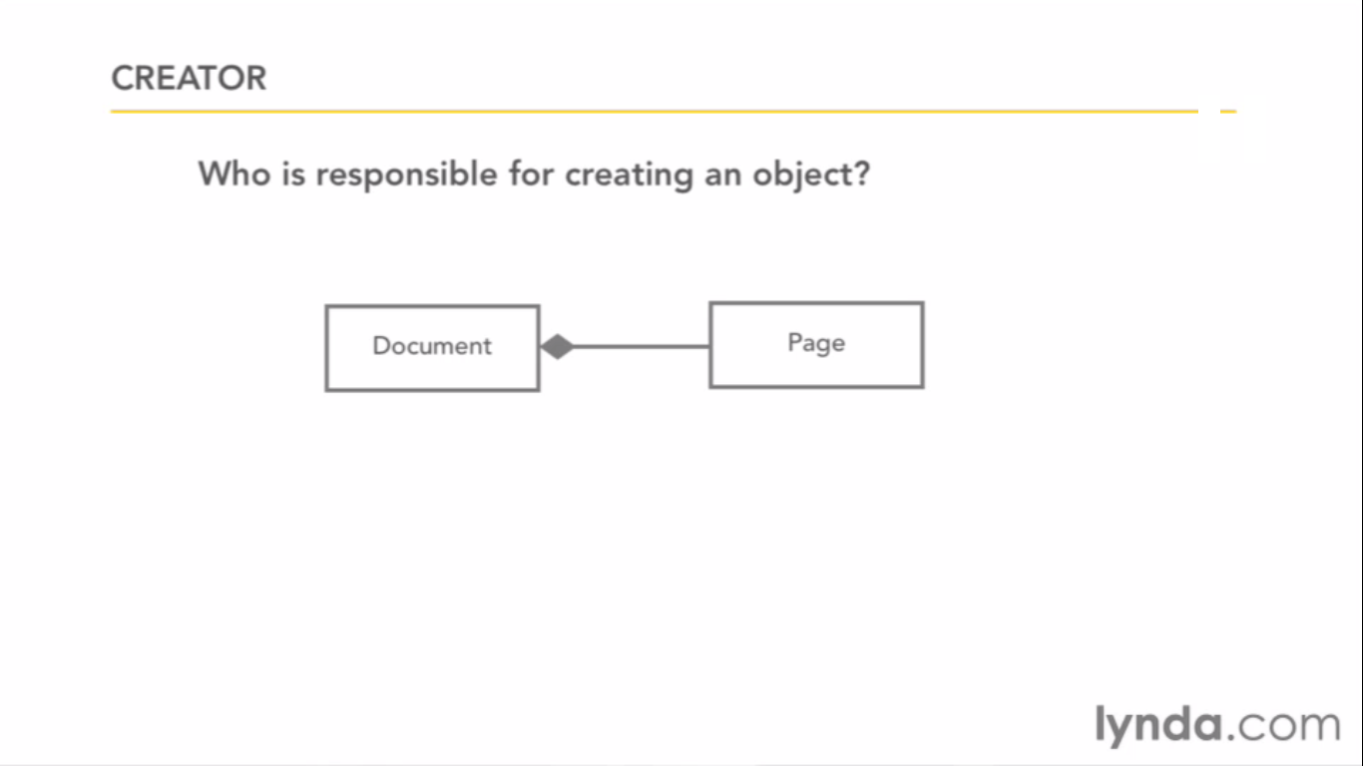

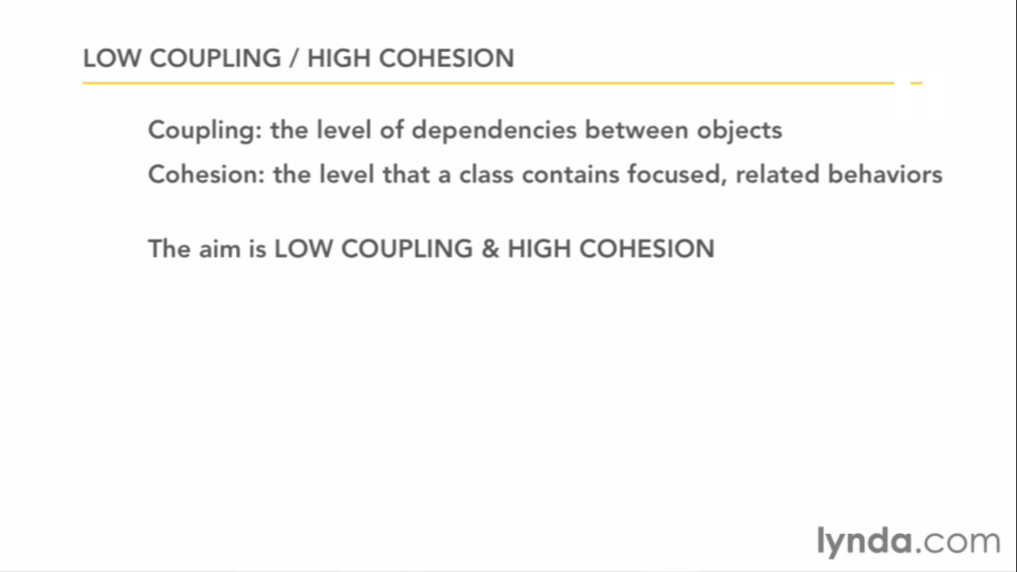

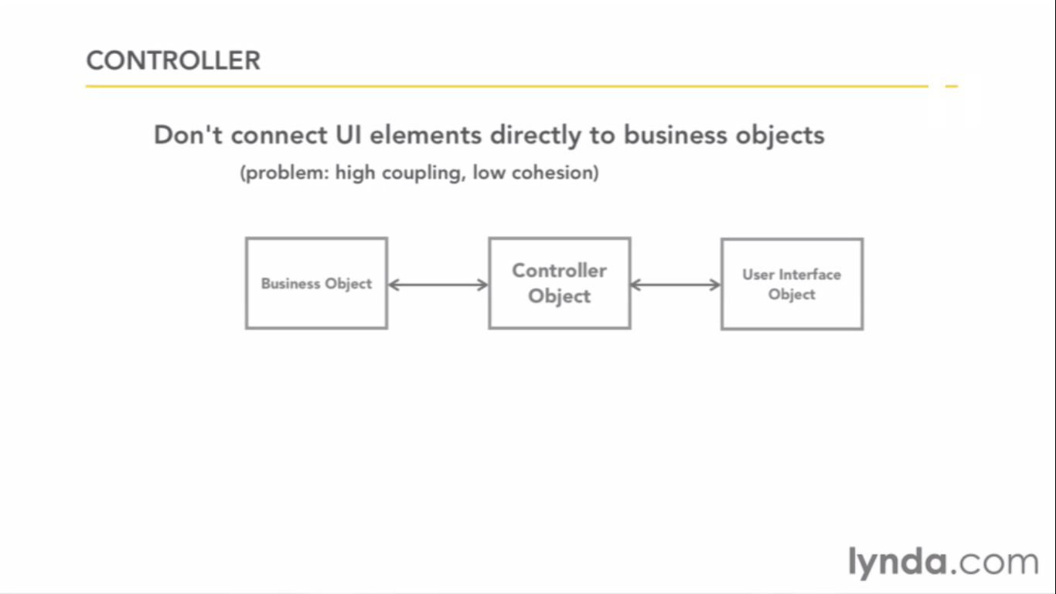

Similar to MVC

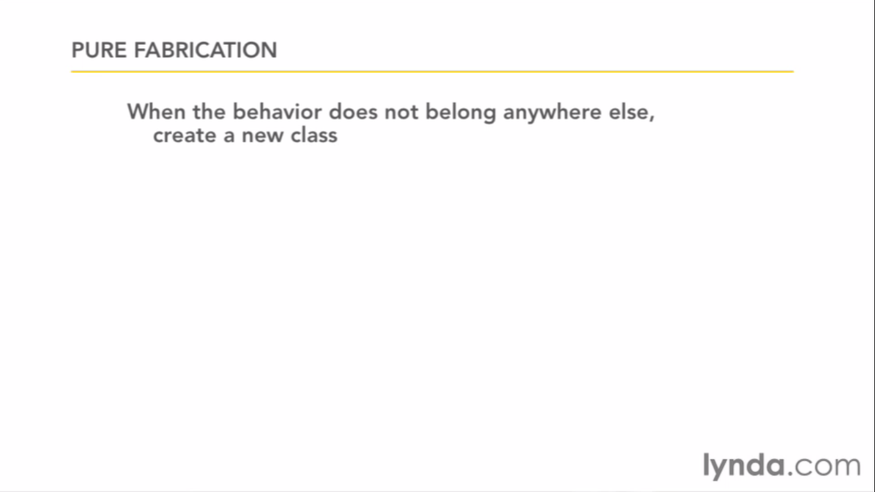

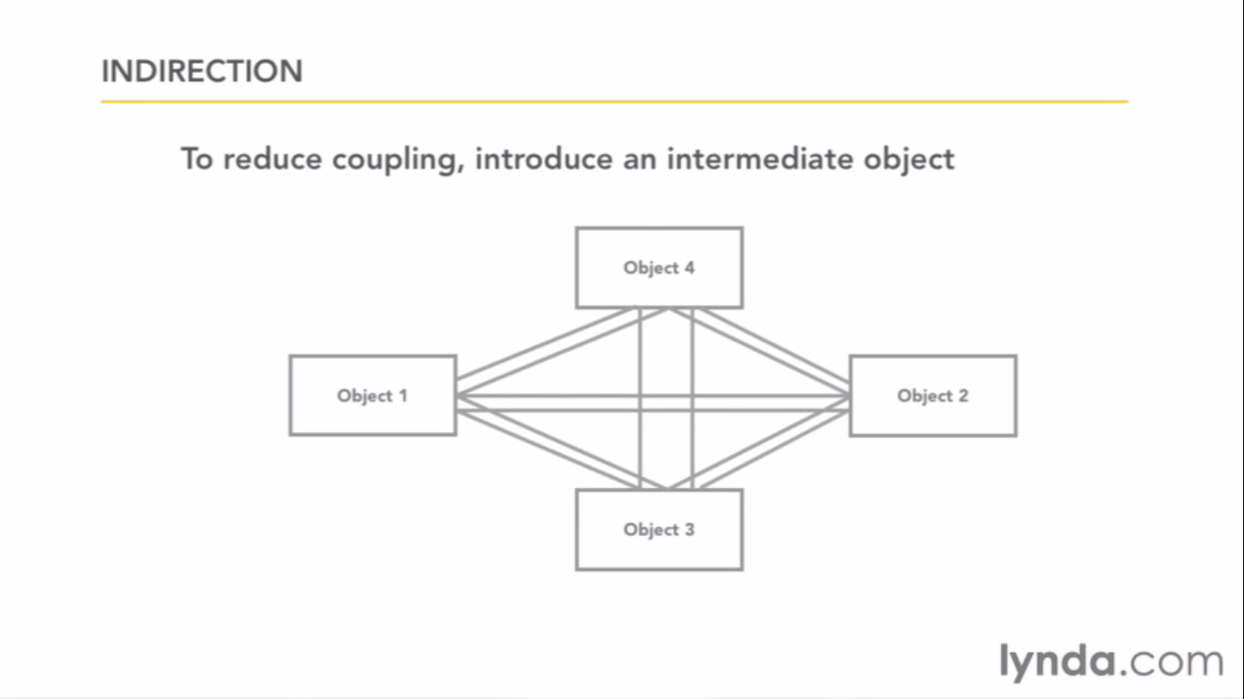

It can be reduced by this

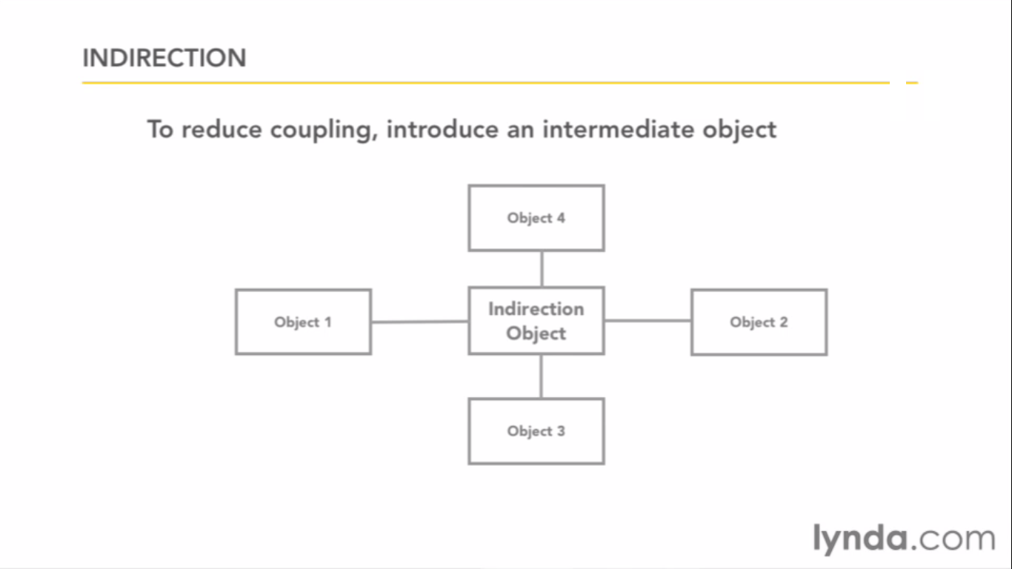

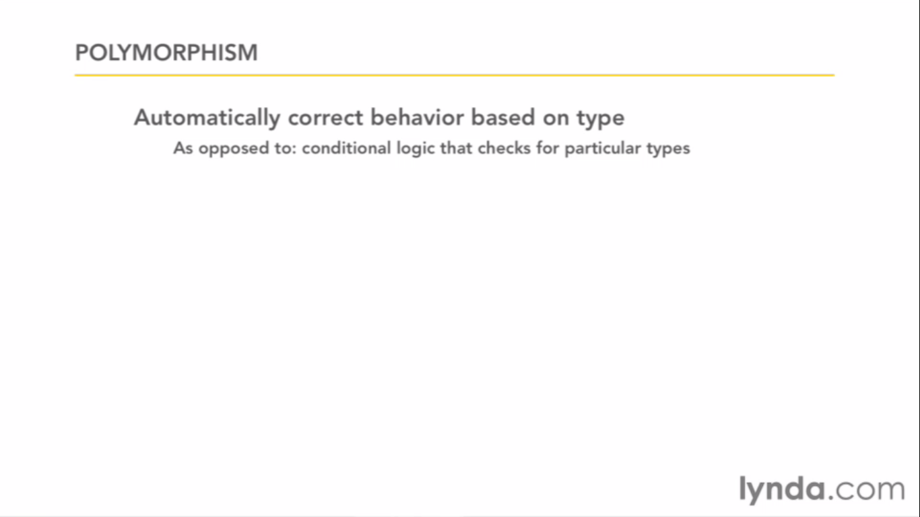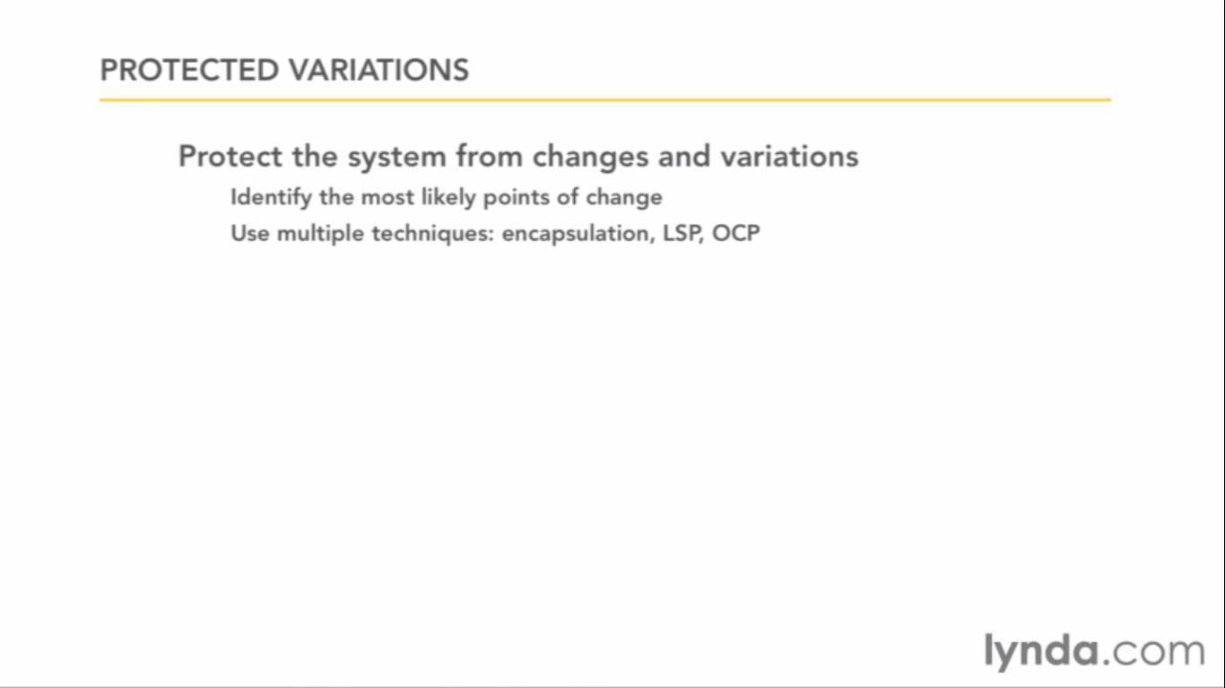

JavaScript don’t have classes they have prototypes.

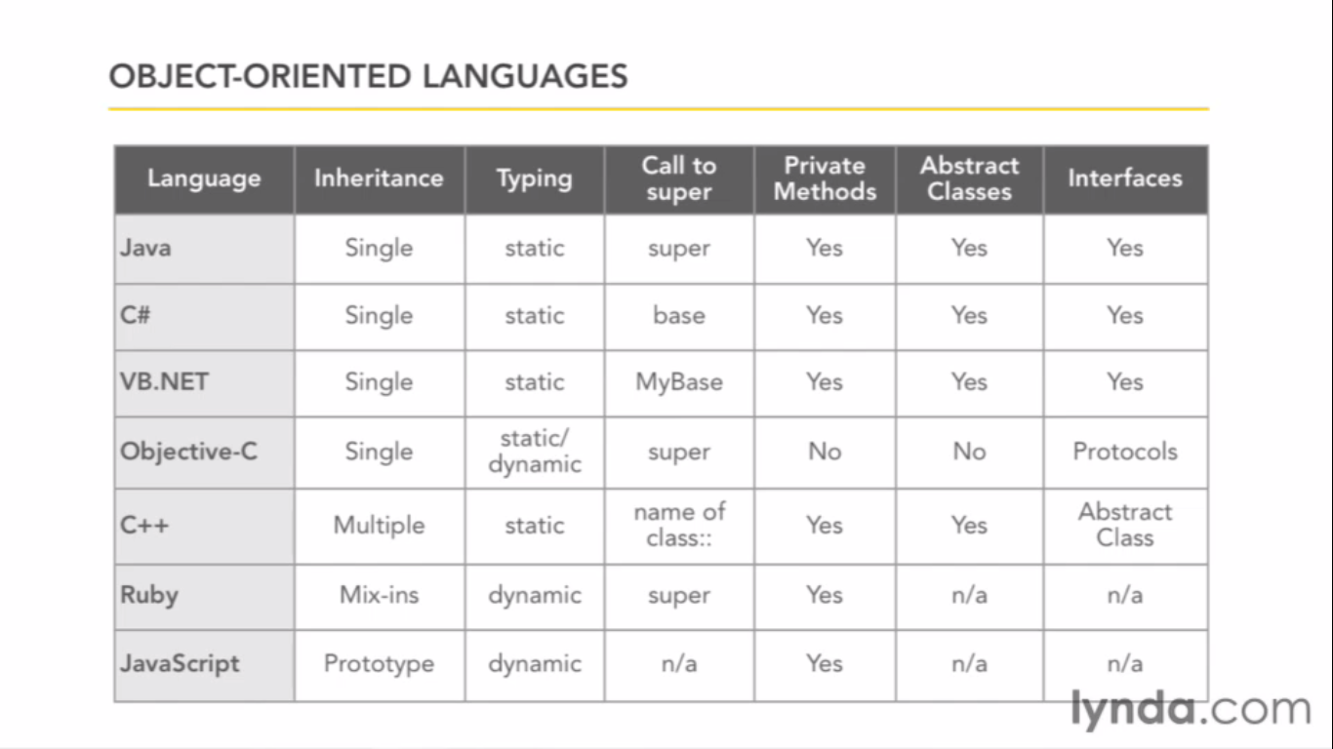

Additional resources

Software Requirements by call whiger

Writing effective use cases

User Stories applied – scrum or extrem programming

UML Distilled 99% uml

Head First Design Patterns

**Build Software make mistakes. Don’t Focus on learning the expense of practice.**

The more you learn is more you realise there is to learn. There is always that you need to know. You will never fully prepared for the project it doesn’t matter begin.

These are the good practices not compulsory they will always work. It just help to not to reinvent the wheel.